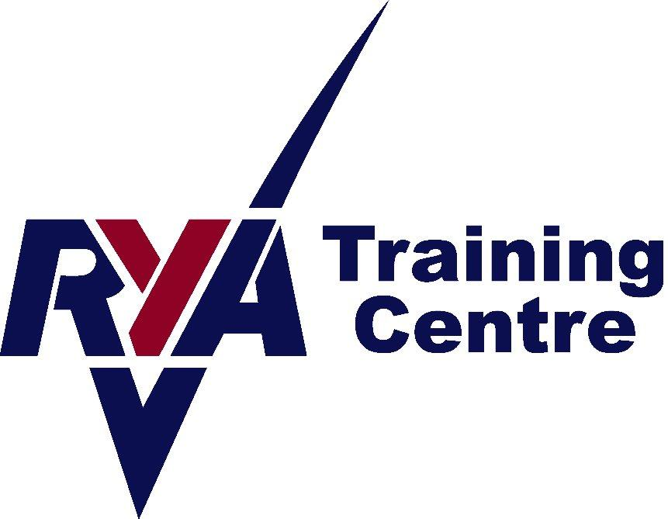



Disability & ASN Sailing Club Info 2024

Peterhead:

We have a little bit of funding left over from our Disability & ASN club in 2023, thanks to the Essentia Foundation. In addition we have little bit of funding from supporters via Just Giving. This will allow us to start our season so initially just the dates until the end of June can be booked. We’re hopeful of being able to secure more funding to complete the season as we go.

Dates are as follows:

Thursday, 16th May, 6.30-8.30pm,
Thursday 23rd May, 6.30-8.30pm
Thursday 30th May, 6.30-8.30pm
Thursday 6th June, 6.30-8.30pm
Thursday 13th June, 6.30-8.30pm
Thursday 20th June, 6.30-8.30pm
Thursday 27th June, 6.30-8.30pm
Thursday 4th July, 6.30-8.30pm
Thursday 11th July, 6.30-8.30pm
Thursday 28th July, 6.30-8.30pm
Thursday 1st August, 6.30-8.30pm
Thursday 8th August, 6.30-8.30pm
Thursday 15th August, 6.30-8.30pm
Thursday 22nd August, 6-8pm
Thursday 29th August, 6-8pm

Please note, there will be no disability club on the 25th July as the road is closed for the Scottish Week.

Sailors are welcome to dress in fancy dress for the last week. We love seeing all your wonderful costumes!

Please note the following:

Wetsuits, buoyancy aids and cag tops are provided. For Wayfarer sailing, if you prefer, you can wear warm clothes & waterproofs. Please note, we do not provide these. You would need to bring your own.

You do need to bring:
A towel
Footwear that can get wet – something like an old pair of trainers or wetsuit boots.
Warm layers (if chilly) e.g fleece or thermal top and hat
Something to wear under their wetsuit- swimwear or T shirt and shorts
Food and drink (e.g. packed lunch, if there for the day)

Also recommended:
Waterproof trousers (may help to help reduce wind-chill on a colder day).
Sun cream

Booking Conditions
A course will not run if there are not enough applicants on it to make it financially viable. We aim to give as much warning as possible in these circumstances. We reserve the right to cancel a course due to lack of bookings or other circumstances. In this instance, a full refund will be given. No refunds will be given for an individual failing to complete a course. In the event of you requiring a cancellation, we will do our utmost to sell your place again and if successful, a full refund will be given. Otherwise, a 50% refund will be given for cancellations with more than 21 days notice from the start date of the course. If less than 21 days from the start date, no refund will be given.

Directions to Peterhead Sailing club

Peterhead Sailing Club is located next to the Marina in Peterhead Harbour, (the Lido). Postcode for Satnav is AB42 2UP

From the south (A90), follow signposts first to the town centre (straight across at the McDonalds round about), and then 2nd right, (signpost towards the Lido caravan park), just before the car park overlooking the bay. This road runs downhill to the water. The sailing club is located halfway between the caravan park and the marina.

From the north (A90) and west (A950), follow signposts to the town centre, and then when in the centre, signposts for Aberdeen. This will bring you to the south side of Peterhead and will bring the harbour into view. Take the left turning towards the Lido caravan park, immediately after the car park overlooking the harbour.

Contact details:
Angie Fraser Tel: 07812 380834 Email: angie@aberdeenshiresailing.org

