
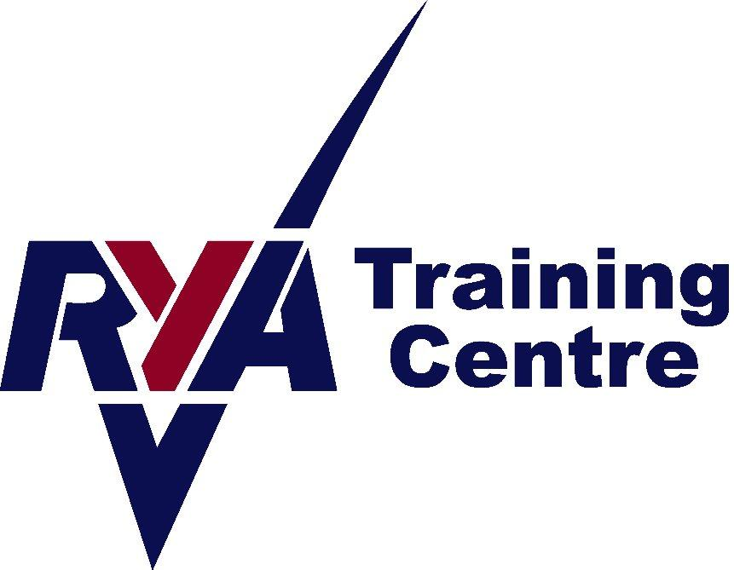

Booking Information

RYA First Aid Course

Venue: Peterhead Sailing Club

Peterhead Sailing Club is located next to the Marina in Peterhead Harbour, (the Lido).

For Satnav, the postcode is AB42 2UP.

There is a Type 2 charger, plus a CCS & Chademo Charger at the top car park on South Road, 5 minutes from the Sailing club for anyone in an EV.

Times: 9.30am-4.30pm

Please wear loose and comfortable clothing, plus as we will need to keep doors open for covid ventilation, please wear warm clothes.

And finally, if you test positive for covid or show any symptoms, please do not come, but instead get in touch for a refund / change of dates.

Tea and coffee are provided. Please bring a packed lunch.

Thank you.

Contact details:
Angie Fraser Tel: 07812 380834 Email: angie@aberdeenshiresailing.org

Booking Conditions

A course will not run if there are not enough applicants on it to make it financially viable. We aim to give as much warning as possible in these circumstances. We reserve the right to cancel a course due to lack of bookings or other circumstances. In this instance, a full refund will be given. No refunds will be given for an individual failing to complete a course. In the event of you requiring a cancellation, we will do our utmost to sell your place again and if successful, a full refund will be given. Otherwise, a 50% refund will be given for cancellations with more than 21 days notice from the start date of the course. If less than 21 days from the start date, no refund will be given.

