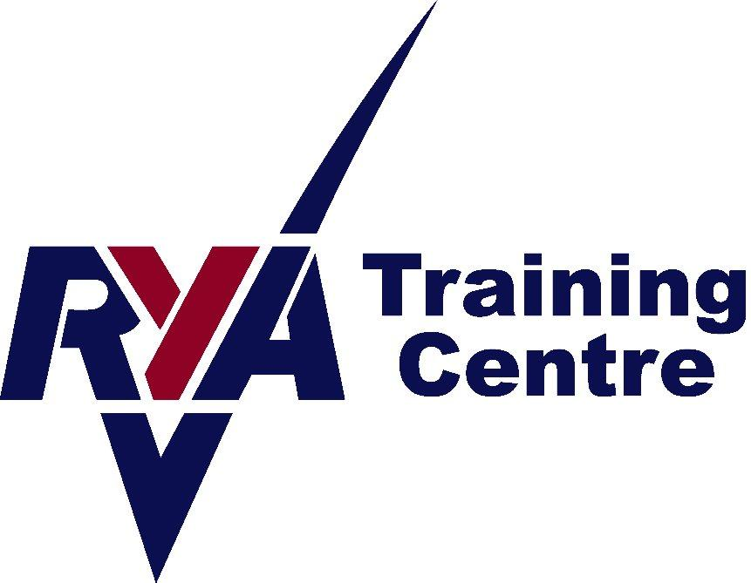


Sailing Information

Please note the following:

We have wetsuits, buoyancy aids and spray tops. We don’t have footwear.

You will need to bring:
A towel
Footwear that can get wet – something like an old pair of trainers or wetsuit boots.
Warm layers (if chilly) e.g fleece or thermal top and hat
Something to wear under your wetsuit- swimwear or T shirt and shorts:

We’d also recommend:
Sun cream
Waterproof trousers. These are a good idea if chilly as they will keep the wind off you & keep you warmer.
A cosy hat

Please bring food & drink if you are there for the day.

RYA Logbooks. If you have a RYA Dinghy or Windsurfing Log book, please bring it with you so we can update it.

Peterhead Sailing club Info

Peterhead Sailing Club is located next to the Marina in Peterhead Harbour, (the Lido).

For Satnav, the postcode is AB42 2UP. There is a Type 2 Charger, plus a CCS & Chademo at the car park on South Road, 5 minutes from the sailing club for anyone coming in an EV.

Loch of Skene Info

Facilities at Skene are limited and as such there are no showers. Showering after sailing at Skene is recommended to reduce any risks of sickness from Blue Green Algae. The nearest showers available are at Westhill Swimming pool, Hays Way, Westhill, AB32 6 XZ. Open Mon-Fridays till 10pm, and at the weekend till 6pm.

Access to Loch of Skene is from the A944 between Westhill and Alford. Turn in towards the Loch at the Gatehouse (about half way along the loch). This is the car parking area. the properties. The tower closest to the road is a private house so we must always leave space for the residents. Please therefore park on the water side / away from this tower.
For Satnav, the postcode is AB32 6YJ

Contact details:
Angie Fraser Tel: 07812 380834 Email: angie@aberdeenshiresailing.org

Booking Conditions

A course will not run if there are not enough applicants on it to make it financially viable. We aim to give as much warning as possible in these circumstances. We reserve the right to cancel a course due to lack of bookings or other circumstances. In this instance, a full refund will be given. No refunds will be given for an individual failing to complete a course. In the event of you requiring a cancellation, we will do our utmost to sell your place again and if successful, a full refund will be given. Otherwise, a 50% refund will be given for cancellations with more than 21 days notice from the start date of the course. If less than 21 days from the start date, no refund will be given.

