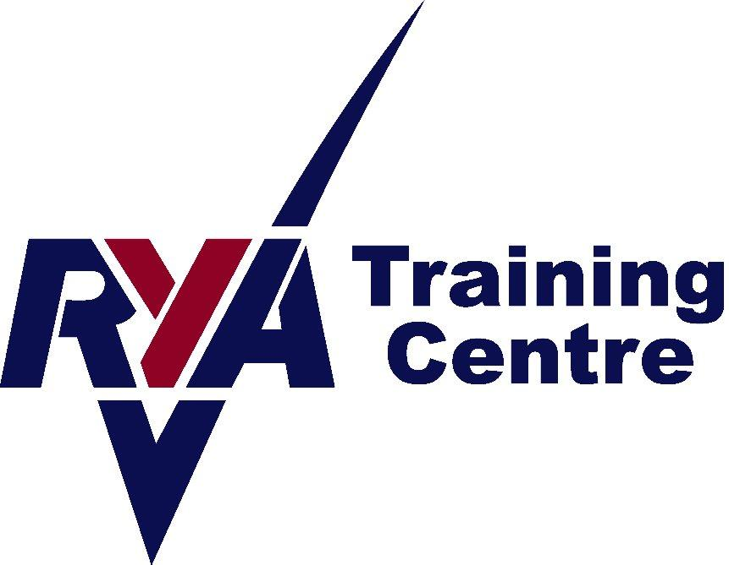


RYA Powerboat Level 2 Course Information

We have wetsuits, buoyancy aids and cag tops at Peterhead. However for powerboating you will normally be comfier in waterproofs and warm clothes. If you have waterproofs, please bring these as it would be much better than wearing our wetsuits. You will also need to bring footwear with rubber soles, welly boots or trainers would be ideal. Your feet might get wet. A warm hat would also be a good idea.

Students also need to bring a packed lunch. Warm drinks are available in the clubhouse. Your certificate will require a passport sized photo, so please bring one on the day.

Our Powerboat Level 2 Courses run from 10am-4.30pm, both days.

Peterhead Sailing club Info

Peterhead Sailing Club is located next to the Marina in Peterhead Harbour, (the Lido).

For Satnav, the postcode is AB42 2UP. We will meet at the clubhouse.

There is a Type 2 charger, plus a CCS & Chademo Charger at the top car park on South Road, 5 minutes from the Sailing club for anyone in an EV.

Contact details:
Angie Fraser Tel: 07812 380834 Email: angie@aberdeenshiresailing.org

Booking Conditions

A course will not run if there are not enough applicants on it to make it financially viable. We aim to give as much warning as possible in these circumstances. We reserve the right to cancel a course due to lack of bookings or other circumstances. In this instance, a full refund will be given. No refunds will be given for an individual failing to complete a course. In the event of you requiring a cancellation, we will do our utmost to sell your place again and if successful, a full refund will be given. Otherwise, a 50% refund will be given for cancellations with more than 21 days notice from the start date of the course. If less than 21 days from the start date, no refund will be given.

