Chelmarsh Sailing Club
Affiliated to the Royal Yachting Association
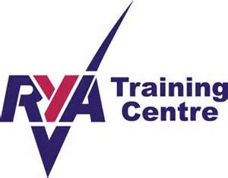

YOUTH SAILING INFORMATION SHEET

Clothing
Wear warm and comfortable clothing. Several layers are best, tee-shirts, thin jumper or a sweatshirt is suitable. Thermal wear is ideal, tracksuit bottoms or cords are suitable. A wetsuit is not essential but if you have one you may want to wear it. There may be some spare wetsuits and wet boots in the training room. Protect yourself against sunburn by wearing a sunhat and applying sun creams. If the sun is strong then sunglasses may help with cutting down the glare off the water. Avoid cotton blouses or shirts, jeans, Arran jumpers and shorts (however knee length trousers are useful)

Footwear
Your feet will get wet. We recommend trainers with socks or sailing boots.

Windproof
If you have a nylon anorak or windproof jacket wear it. Even in summer the weather can be wet and chilly.

Buoyancy aids
Everyone is required to wear a buoyancy aid at all times whilst you are on the water and on the pontoons.
Buoyancy aids are available free of charge whilst on the course.

Valuables
There are already sufficient pairs of spectacles at the bottom of the reservoir. If you wear glasses make sure they are tied on. Please leave money, mobile phones and other valuables somewhere safe. It is wise not to bring any unnecessary items of this nature with you.

Capsizes are inevitable, so please ensure you bring a spare set of clothing with you to each session to change into afterwards. Students must be able to swim and be water confident.
Hot showers are available so bring a towel too.
You will need to bring a picnic lunch. There are soft drinks, tea and Coffee available. There is not time to leave the premises for lunch.

Attendance
Attendance at both sessions is very important or else you may not progress sufficiently to complete the course. If you are incapable of attending any session please contact your course leader so he/she can inform your instructor in time.

Notice to Parents
If possible please remain on site during your child’s training session, you can assist in the course and help you child, so that you can provide assistance after the course as they progress further.
At the end of each session please make sure you let the course leader know before you take your child/children home.

We look forward to seeing you on the course.
Website www.chelmarshsailing.org.uk

