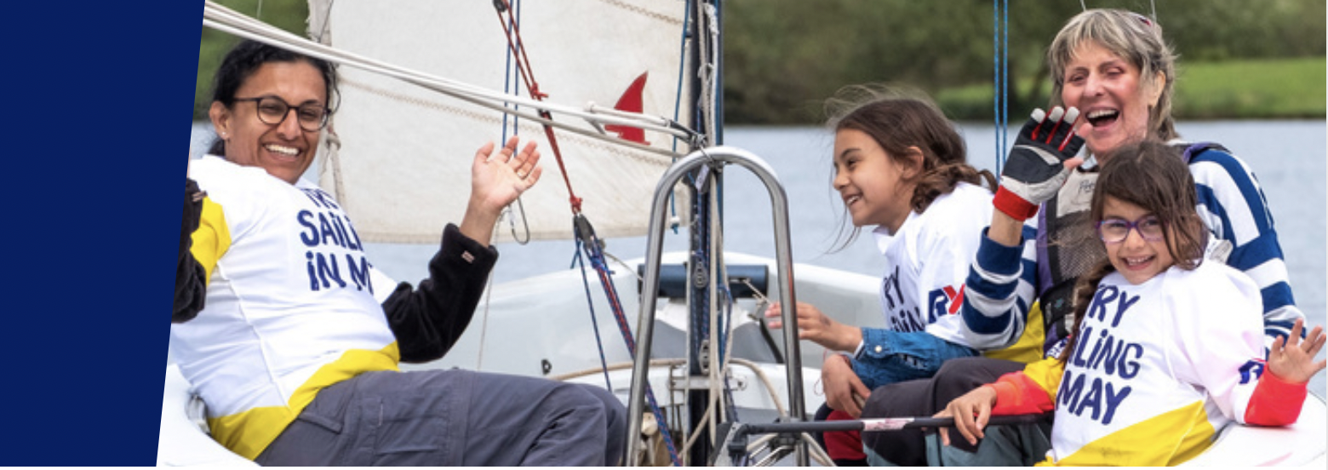
Discover Sailing - 21 June 2025 11-3pm
MAIN PARTICIPANT CONTACT DETAILS
Name

Address

Contact no.

Email Address
If you are under 18, your parent or guardian must complete and sign the Parent/ Guardian Consent Form below.

ABOUT YOU Do you have any previous boating experience
or qualifications?

If yes, please give brief details.

Can you swim 25 meters?

In the interests of your safety do you have any medical
conditions or physical or mental impairments that the
Organiser needs to be aware of that may affect your
ability to take part in the DS Event?
Yes / No
If you answer yes please provide further details in the Medical Information and Impairments section of this form.
Telephone number of emergency contact.

ABOUT OTHERS in your group (from the same address)
Name

Name
Name

Name

Please list their
previous boating
experience and/or
qualifications.

Please ensure each member in your group provides details of any medical conditions or physical or mental impairments that the DS Organiser needs to be aware of that may affect their ability to take part in the DS Event in the Medical Information and Impairments section of this form.

BOOKING TERMS

1. RISK STATEMENT
It must be recognised that sailing is by its nature an unpredictable sport and therefore inherently involves an element of risk. By taking part in the DS Event, you agree and acknowledge that:
- You are aware of the inherent element of risk involved in the sport and you accept responsibility for exposing yourself to such inherent risk whilst taking part in the DS Event;
- You will comply at all times with the instructions of the DS Event volunteers particularly with regard to instructions for boarding and leaving the boat and/or launching and recovery (as relevant), using the equipment on the boat and handling sails, wearing of buoyancy aids, lifejackets and the wearing of suitable clothing in particular footwear for the conditions;
- You accept responsibility for any injury, damage or loss to the extent caused by your own negligence;
- You will not participate in the DS Event if your ability to participate is impaired by alcohol, drugs or if you are otherwise unfit to participate;
- You will inform the DS Event Co-ordinator if there have been any changes to the information provided on this form at the time of the Event.
- The provision of supervision by the DS Organiser is limited to such assistance, as can be practically provided in the circumstances.
- You understand that the DS event is intended to give participants a chance to experience sailing. You will be offered the chance to take part in the activities under the guidance of a representative of the DS Organiser who has been assessed by the organiser as competent and sufficiently experienced to supervise your experience. These representatives may not be qualified instructors. The DS event is not intended to provide tuition or instruction.
- You are aware of any specific risks drawn to your attention by the DS Event Co-ordinator.
The Organiser very much hopes that you will enjoy the DS Event and will be able to advise you on how to obtain tuition and instruction should you wish to take your experience to the next stage.
2. CANCELLATION
You understand that the DS Event Co-ordinator may cancel or postpone the DS Event at any stage in the event of bad weather, equipment failure or otherwise.
3. MISCONDUCT
You understand that the DS Event Co-ordinator may exclude anyone from a particular session and evict anyone from the premises who refuses to comply with these Booking Terms or who misconducts themselves in any way or who causes damage or annoyance to other persons.

BOOKING TERMS (cont)

4. DATA PROTECTION
Chew Valley Lake Sailing Club has a Data Privacy Policy which can be found at: https://www.chewvalleysailing.org.uk/wp-content/uploads/documents/CVLSC-Data-Privacy-Policy.pdf
Your data will be stored and used in accordance with that policy.
The information you provide in his form will be used to facilitate your participation in the DS Event and to contact you. The Organiser would also like to include your contact details on a mailing list in order to make you aware of membership opportunities and future events.
If you would like to be included on this mailing list please tick here.

If you wish to withdraw your consent at any time, please contact vice-president@chewvalleysailing.org.uk

5. PHOTOGRAPHY
The DS Organiser may arrange for photographs or videos to be taken at the DS Event and published on the Event or Organisers website or social media channels to promote the Event or Organiser. This imagery may also be used by the RYA in connection with the promotion of its activities.
If you consent to the use of images of you being used for this purpose, please tick here.

If you are taking part in the DS Event as a family, your family members, aged 18 and over, should indicate their consent to the use of their image separately below.

Family member

Family member
Family member
PARENTAL/GUARDIAN CONSENT (if children under 18) If you consent to the use of your child’s image being used for the purposes above please tick here.
By consenting to the use of your child’s image being used, you confirm that that your child is not under a court order which may prevent their image from being published.
If you/ the individuals listed above later wish to withdraw consent, please contact commodore@chewvalleysailing.org.uk
Please be aware that if you later decide to withdraw your consent it will not be possible to remove your image from any printed material in circulation, or until the next edition or print of the item containing your image is released.
By agreeing to your images being used, you agree to assign any copyright or any other right of ownership of these images to the Organiser.

6. DOGS. Please note that Dogs are not permitted on our site, even if kept in a car.

AGREEMENT (to be signed by all persons over 18)
I confirm that I have read and fully understand the above Booking Terms and agree to comply with them.
Signed (The Participant) Date

Signed (The Participant) Date
PARENTAL/GUARDIAN AGREEMENT (if children under 18)

Name of parent/guardian completing this form Relationship to participant
Supervision (tick one box)
I will be responsible for my child throughout the event. I will be available at the event venue
OR
I appoint the person named below, who has agreed to act in loco parentis. He/she will be responsible for my dependant throughout the event. He/she will be available at the event venue

Name of person appointed in loco parentis Mobile number

I agree that may take part in the Event. I confirm that I have read through the above conditions with him/her and that she/he understands and agrees with them. I also confirm that he/she takes part in the Event with my full agreement that that the particulars given above are correct and complete in all respects.

Signed Parent/Guardian Date

Please note: Dogs are not permitted in any circumstance on the club grounds, even if kept in cars

MEDICAL INFORMATION AND IMPAIRMENTS
If you declared that you have a medical condition or physical or mental impairment that the organiser needs to be aware of because it may affect your ability to take part in the Event please provide details below.

SPECIAL CATEGORY DATA: I confirm that I have given the Organiser the medical information listed above (if any) for the purposes of my participation in the Event. I understand that this information will only be used for that purpose and will be retained for as long as necessary to comply with the Organisers legal obligations.
I agree / I do not agree (Please delete as appropriate)

PLEASE RETURN FORM TO: commodore@chewvalleysailing.org.uk

