1 RULES
1.1 The races will be governed by the Rules as defined in the Racing Rules of Sailing
1.2 The event will also be governed by Local Instructions that will be available at registration.
2 ADVERTISING
2.1 Boats may be required to display advertising chosen and supplied by the organizing authority.
3 ELIGIBILITY AND ENTRY
3.1 The regatta is open to Dart 18 class boats.
3.2 Boats may enter on the day
3.3 It is a requirement for Boats to be members of UKIDA
3.4 Entries will also be accepted at the time of registration. Cash payment only, no cheques.
4 FEES
4.1 Single handed crew £25.00 (Main Sail only), Early bird £20 till 12 June
4.2 Double Handed £50.00 (Main Sail and Jib), Early bird £40 till 12 June
5 SCHEDULE
5.1 Registration: from 10.00am on Saturday 20th June 2026
5.2 Competitor Briefing: will be at 10.55am on Saturday 20th June 2026.
5.3 Six Races are scheduled to be sailed. Three Races on Saturday and Three on Sunday.
5.4 The Race Committee reserves the right to re-schedule races which, for whatever reason, may not be sailed as scheduled. In such an event, no more than 4 races will be sailed on the same day.
5.5 The scheduled time of the warning signal for the first race will be 11.55am on Saturday 20th June and 10.55am on Sunday 21st June. Subsequent races will sailed as scheduled.
6 MEASUREMENTS
6.1 All competing boats shall comply with the UKIDA rules,
7 SAILING INSTRUCTIONS
7.1 Sailing Instructions and Local Instructions will be available at registration.
8. VENUE
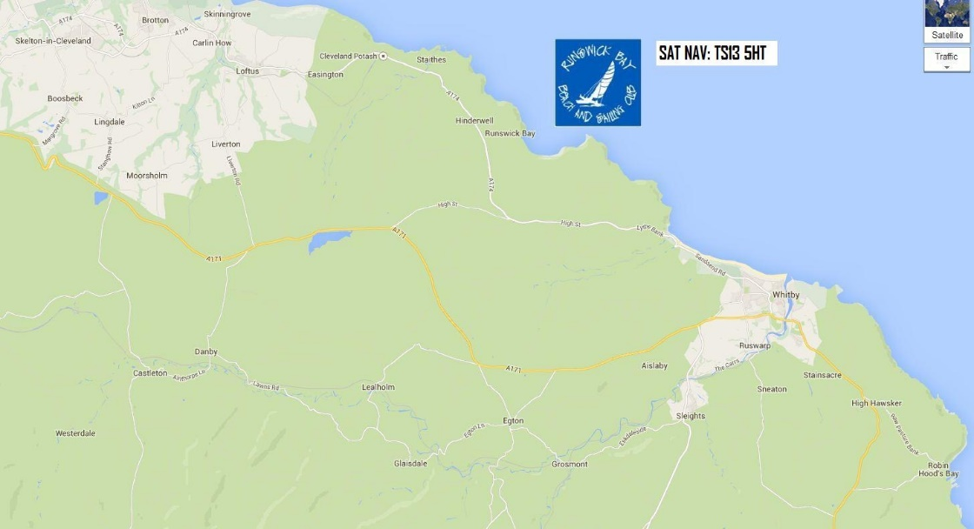
8.1 Map shows the location of Runswick Bay Beach & Sailing Club, North Yorkshire

8.2 Map shows the location of the racing area, up to 1.5 Nautical Miles
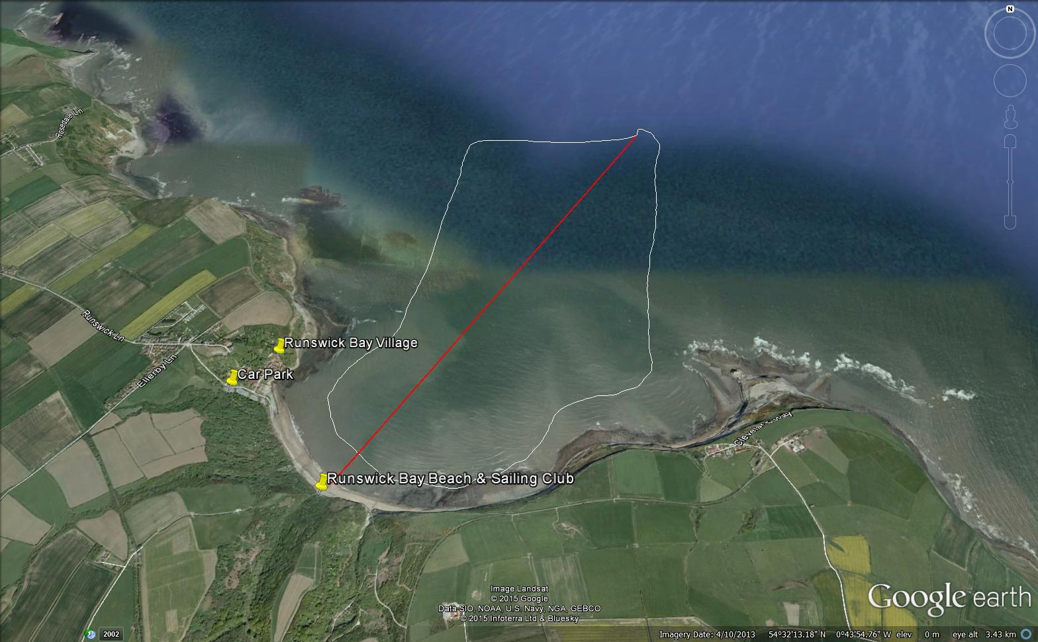

9 COURSES
9.1 The courses will be shown in the sailing instruction and will either be triangular in format, or windward/leeward with an offset mark at the windward mark.
10 PENALTY SYSTEM
10.1 Rule 44.1(a) is changed so that a boat that may have broken a rule of Part 2 in an incident whilst racing may take a penalty consisting of only one turn, including one tack and one gybe.
11 SCORING
11.1 2 races shall be completed to constitute a series.
11.2 When 4 or more races have been completed a boat’s series score will be the total of her race scores, excluding her worst score.
11.3 When fewer than 4 races have been completed, a boat’s series score will be the total of her race scores.
12 BERTHING
12.1 Boats may be left in the RBBSC Boat Park the previous and following weekends by prior arrangement.
12.2 All boats (including club members' boats) shall be parked on the beach during the event unless otherwise advised by the Race Committee.
12.3 Boats arriving, due to tides, on Friday access restricted from 6:30pm – 10pm, on Saturday from 7:00am – 10:30am before being taken along the beach. Rigging and launching can be at the village end of the beach if required.
12.4 Visitors wishing to depart promptly following the last race on Sunday, due to tides, access to remove boats from the beach will be up to 8:pm.

13 RADIO COMMUNICATIONS
13.1 Except in an emergency a boat shall neither make radio transmissions while racing nor receive radio communications not available to all boats. This restriction also applies to mobile telephones.
14 PRIZES
14.1 Prizes will be awarded to the boat placing first, second, third, fourth & fifth as appropriate depending on numbers of entries, thereafter.

15 RISK STATEMENT.

15.1 Rule 4 of the Racing Rules of Sailing states “The responsibility for a boat’s decision to participate in a race or to continue racing is hers alone.”

15.2 Sailing is by its nature an unpredictable sport and therefore inherently involves an element of risk. By taking part in the event, each competitor agrees and acknowledges that:

15.2.1 They are aware of the inherent element of risk involved in the sport and accept responsibility for the exposure of themselves, their crew and their boat to such inherent risk whilst taking part in the event;

15.2.2 They are responsible for the safety of themselves, their crew, their boat and their other property whether afloat or ashore;

15.2.3 They accept responsibility for any injury, damage or loss to the extent caused by their own actions or omissions;

15.2.4 Their boat is in good order, equipped to sail in the event and they are fit to sail:

15.2.5 The provision of a race management team, patrol boats and other officials and volunteers by the event organizer does not relieve them of their own responsibilities:

15.2.6 The provision of patrol boat cover is limited to such assistance, particularly in extreme weather conditions, as can be practically provided in the circumstances; 14.2.7

15.2.7 Their boat is adequately insured, with cover of at least £3,000,000 against third party claims and shall sign a declaration to that effect on their entry form.

