Notice of Race
Cambs Youth Sailing League Series
Grafham Meeting Saturday 21 May 2022
The organising authority is Grafham Water Sailing Club (“GWSC”) in conjunction with the Cambs Youth Sailing League.
- RULES
  - The event will be governed by rules as defined in The Racing Rules of Sailing 2021 - 2024.
  - Competitors should note that GWSC implements the RYA Racing Charter and that they will be expected to sail in compliance with it. The charter can be found at the front of the RYA edition of the Racing Rules of Sailing 2021-2024 (the yellow pages after the definitions), or on the RYA website at www.rya.org.uk/racingrules.
  - COVID STATEMENT - All sailors, parents and authorised guests must comply with any prevailing Government Rules or Regulations and with GWSC COVID-19 Operating Procedures available at: https://www.grafham.org/covid-19-operating-procedures.html
Competitors and support persons shall comply with any reasonable request from an event official. Failure to comply may be construed as misconduct.
Reasonable actions by event officials to implement COVID-19 guidance, protocols or legislation, even if they later prove to have been unnecessary, are not improper actions or omissions.
- SAILING INSTRUCTIONS
  - The event Sailing Instructions will be available on the Club Web Site at https://www.grafham.org/open-meetings-entry by 20:00 on Thursday 19 May 2022.
  - The CYSYA Supplemental Sailing Instructions for the Series also apply: these are available at Rules (csysa.org.uk)
- COMMUNICATION
  - The official notice board will be online, located at https://www.grafham.org/online-noticeboard.html
  - Notices for competitors will be posted on the official notice board. It is expected that there will be a Competitor briefing on the day, details of which will be made available with the Sailing Instructions
  - From the first warning signal until the end of the last race of the day, except in an emergency, a boat shall not make voice or data transmissions and shall not receive voice or data communication that is not available to all boats.
- ELIGIBILITY AND ENTRY
  - Competitors shall be under the age of nineteen years (19) on 31 August 2022.
  - Competitors shall be members of one of the participating clubs: Grafham Water SC, Cam SC, Ely SC, Hunts SC, and Paxton Lakes SC, or otherwise specifically invited by CSYSA
  - The event is open to any class of dinghy or multihull with a Portsmouth Yardstick Number. The prescriptions of Clause 3 Rules (csysa.org.uk) apply.
  - Boats may enter the event by completing the online entry form at https://www.grafham.org/open-meetings-entry together with the required entry fee, by midnight on Wednesday 18 May 2022.
  - To be considered an entry in the event, a boat shall complete all registration requirements and pay all fees.
  - Late entries will be accepted only at the absolute discretion of GWSC.
  - The following restrictions on the number of boats apply:
    - Maximum entry limited to 50 boats
  - COVID ENTRY RESTRICTIONS
    - The Club reserves the right to refuse entries from boats where participation in the event would be in violation of any COVID restrictions then applying.
- FEES
  - The entry fee is £1 per boat.
- CREW LIMITATIONS
Class rules apply.
- ADVERTISING
Boats may be required to display advertising chosen and supplied by the organizing authority.
- QUALIFYING SERIES AND FINAL SERIES – N/A
- SCHEDULE
  - Registration will be done on entry to the site from 09:00 on Saturday 21 May 2022
  - Equipment inspection and event measurement: N/A
  - Date of Racing: Saturday 21 May 2022
  - Three races are scheduled with the first race, first flight, warning not before 11:27am. It is envisaged there will be up to three flights in each race: fast, medium and slow. Racing will be handicap racing using PY numbers (as amended by National Class rules) and average lap times
  - At the discretion of the Race Officer races 2 and 3 may be “back to back”. This will be announced on the day
- EQUIPMENT INSPECTION
  - Each boat may be required to produce or verify the existence of a valid measurement certificate.
- CLOTHING AND EQUIPMENT
  - RRS40.1 shall apply at all times when afloat.
- VENUE
  - A site plan showing, parking and slipways is shown in Appendix 1.
- COURSES
  - The course to be sailed will be a trapezoid with an upwind gate and will be described in the Sailing Instructions
- PENALTY SYSTEM
  - Independent judging may be applied as per Rules (csysa.org.uk)
- SCORING
  - One race is required to be completed to constitute a series for this event
  - (a) When fewer than three races have been completed, a boat’s series score will be the total of her races scores.
(b) When three races have been completed, a boats series score will be the total of her race score excluding her worst score.
  - RRS 90.3e shall apply.

- SUPPORT PERSON VESSELS
  - Support vessels shall not be allowed unless expressly authorised by the Race Committee
- , 18, 19, 20 DO NOT APPLY
- DATA PROTECTION
  - The GWSC data protection policy can be found at https://www.grafham.org/wp-content/uploads/_pdfs/Club%20Documents/Privacy-Notice.pdf
- RISK STATEMENT
Rule 3 of the Racing Rules of Sailing states: ‘The responsibility for a boat's decision to participate in a race or to continue racing is hers alone.’
Sailing is by its nature an unpredictable sport and therefore inherently involves an element of risk. By taking part in the event, each competitor agrees and acknowledges that:
(a) They are aware of the inherent element of risk involved in the sport and accept responsibility for the exposure of themselves, their crew and their boat to such inherent risk whilst taking part in the event;
(b) They are responsible for the safety of themselves, their crew, their boat and their other property whether afloat or ashore;
(c) They accept responsibility for any injury, damage or loss to the extent caused by their own actions or omissions;
(d) Their boat is in good order, equipped to sail in the event and they are fit to participate;
(e) The provision of a race management team, patrol boats and other officials and volunteers by the event organizer does not relieve them of their own responsibilities;
(f) The provision of patrol boat cover is limited to such assistance, particularly in extreme weather conditions, as can be practically provided in the circumstances;
(g) It is their responsibility to familiarise themselves with any risks specific to this venue or this event drawn to their attention in any rules and information produced for the venue or event and to attend any safety briefing held for the event.
- INSURANCE
  - Each participating boat shall be insured with valid third-party liability insurance with a minimum cover of £2,000,000 per incident or the equivalent.
- PRIZES
  - Prizes will be given as set out in Rules (csysa.org.uk)
- FURTHER INFORMATION
  - COVID-19 INFORMATION
    - We may need to impose restrictions both onshore and offshore depending on the prevailing Covid-19 situation. The nature of any restrictions will be communicated to competitors in the pre-event briefing note. By 20:00 on Thursday 19 May 2022 a final decision will be made on whether the event can proceed based on the forecast wind strength and any change in COVID-19 restrictions. In the event of any cancellation a notice will appear on the GWSC website by this time.
  - GENERAL
The cafeteria will be open from 09:00 until approximately 17:00 on Saturday 21 May,
Directions to Grafham Water Sailing Club, details of local accommodation, and other information are available on the Club website - http://www.grafham.org .
Entrants and authorised guests are temporary members of Grafham Water Sailing Club during the period of the event and shall comply with Club Rules and Bylaws. Failure to observe these may result in exclusion from the club premises.
  - MOVEMENT OF BOATS TO GRAFHAM WATER
In order to prevent the spread of non-native species there is a requirement to ensure that boats are clean before they visit the site using the principle of Check Clean Dry http://www.nonnativespecies.org/checkcleandry/index.cfm . This includes:
CHECK your equipment and clothing for live organisms – particularly in areas that are damp or hard to inspect.
CLEAN and wash equipment, footwear and clothing thoroughly. If you do come across any organisms, leave them at the water body where you found them.
DRY all equipment and clothing – some species can live for many days in moist conditions. Make sure you don’t transfer water elsewhere.
Anglian Water ask for boats and equipment, arriving at Grafham Water that are from the following locations, to have been clean and dry for at least two days prior to arrival – if not, then they must not be launched at the Club:
- Wraysbury Reservoir and Wraysbury River near to Staines
- The Queen Mother Reservoir
- Queen Elizabeth II/Bessborough Reservoirs
- Queen Mary Reservoir
- Warwick East Reservoir, Warwick West Reservoir and William Girling Reservoir all located in the Lee Valley

  - MOVEMENT OF BOATS FROM GRAFHAM WATER
A non-native species of fresh-water shrimp (commonly known as killer shrimps) have been found in Grafham Water and certain restrictions on boat movement have been imposed by AW, DEFRA or other bodies to prevent the spread of these to other locations in the UK. These requirements are prominently displayed on the club premises and will include washing boats and equipment before removal from the Club premises.
Failure to comply with the requirements of these restrictions may lead to expulsion from the event.
25.5 PHOTOGRAPHER
Professional Photographs - Our photography partner, Paul Sanwell of OP Photography may be taking action photographs of the event.
These images can be viewed and purchased the day after the event on the Grafham Water SC photo-gallery at www.grafham.org/photos .

APPENDIX 1 – SITE PLAN
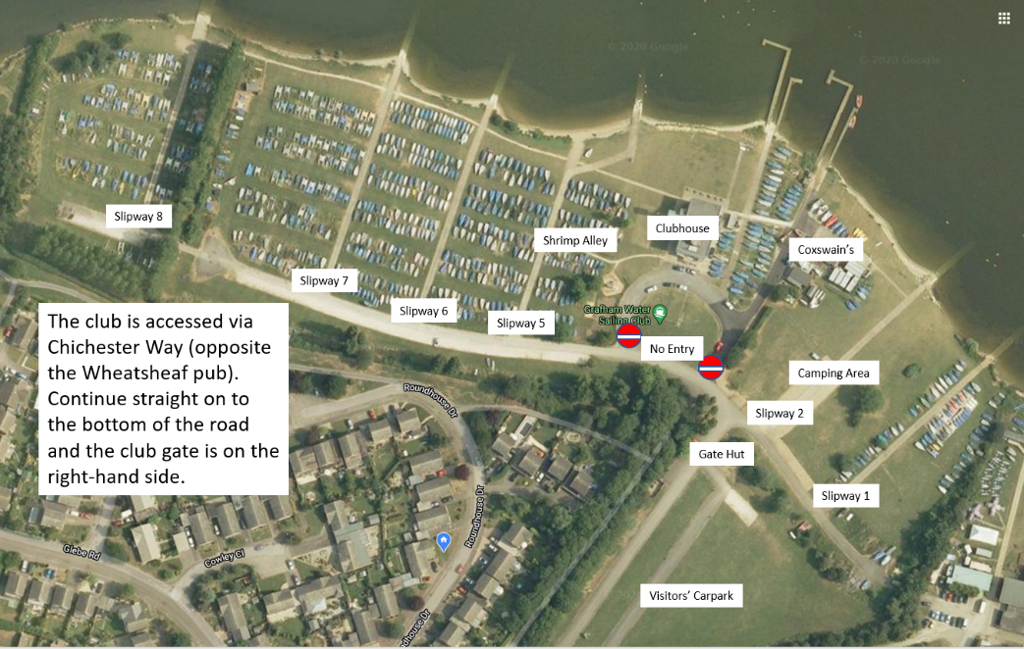

Grafham Water Sailing Club, Perry, Huntingdon PE28 0BU
Tel: 01480 810478 email: office@grafham.org website www.grafham.org

