
Sailing Instructions
Duke of Edinburgh Trophy Regatta 2025

[DP] before a rule indicates that penalty other than disqualification may be applied by the Race Committee.
[NP] Before a rule indicates that a boat may not protest another boat for breaking that rule. This changes RRS60.1a

- RULES
  - The event is governed by the rules as defined in The Racing Rules of Sailing 2025 - 2028.
  - SAIL NUMBERS
    - A boat shall not race with an incorrect sail number unless she has notified the office when entering. Even when such confirmation is received the Race Committee does not have the authority to amend the requirements of class rules. As a result, a boat could be protested for failing to comply with class rules.
- CHANGES TO SAILING INSTRUCTIONS
  - Any change to the sailing instructions will be posted no later than 0900 on the day it will take effect except that any change to the schedule of races will be posted by 2000 on the day before it will take effect.
- COMMUNICATIONS WITH COMPETITORS
  - Notices to competitors will be posted on the official notice board located at
https://www.grafham.org/club-noticeboard.html
  - From the first warning signal until the end of the last race of the day, except in an emergency, a boat shall not make voice or data transmissions and shall not receive voice or data communication that is not available to all boats.
- CODE OF CONDUCT
  - [DP] Grafham Water Sailing Club implements the RYA Racing Charter and competitors will be expected to sail in compliance with it. The Charter can be found at the front of the RYA edition of the Racing Rules of Sailing (the yellow pages after the definitions), or on the RYA website at www.rya.org.uk/racingrules.
- SIGNALS MADE ASHORE
  - Signals made ashore will be displayed on flagpole 1. Signals may be announced on the tannoy as well.
  - When flag AP is displayed ashore ‘1 minute’ is replaced with ‘not less than 30 minutes’ in the Race Signal AP.
- SCHEDULE OF RACES
  - Scheduled race times
Scheduled starting signal | Start 1 |  | Start 2 |  | Start 3
Race 1 | 1100 | 1103 |  | 1106
Race 2 | Back to back
Race 3 | Back to back
  - The first warning signal shall not be before 1057.
  - To alert boats that a race or sequence of races will begin soon, the orange starting line flag will be displayed with multiple sound signals at least one minute before the first warning signal is made.
- CLASS/FLEET FLAGS
7.1 No class or fleet flags will be used for starting signals.
- RACING AREA
  - The racing area will be where the committee boat anchors.
- THE COURSES
  - The courses are described in Addendum A.
  - Indicator boards on the committee boat will show the course to be used for the forthcoming race.
  - Boats which fail to start or finish correctly or to sail the course as set and thus fail to comply with RRS28 will be disqualified without protest or a hearing.
  - Boats must pass through the upwind gate formed by the committee boat and the finishing mark on each lap. Boats that fail to pass through the gate will not be disqualified but will be credited only with the number of laps they have sailed correctly. The Race Committee shall record the finishing time or place as appropriate as well as noting on which laps that the gate was missed. Boats may apply for redress if they believe an error has been made. This changes RRS63.1
  - Boats shall not sail through the Finish Gate on the way to a leeward course mark, therefore this gate shall be treated as an obstruction to all boats sailing to their leeward course mark.
- MARKS
  - Marks used will be as described in Addendum A
- [DP] AREAS THAT ARE OBSTRUCTIONS
  - The following areas are designated as obstructions:
    - The prohibited area at the West end of the water is an obstruction. Its boundary is a line of small yellow buoys forming its eastern boundary.
    - Each fishing boat, and an area extending 20 metres in any direction from the fishing boat is a prohibited area and an obstruction.
    - A safety boat in close attendance to a craft or competitor in difficulty is an obstruction and a prohibited area. Boats must not sail between the safety boat and the craft or competitor in difficulty.
- THE START
  - Races will be started by displaying numeral boards to indicate elapsed minutes, with fleets starting at 3 minute intervals. This modifies RRS 26. Details of the start sequence and signals are shown in Addendum B.
  - The starting line will be between the mast displaying the orange flag on the committee boat and a dan buoy displaying an orange flag.
  - [DP] Boats whose warning signal has not been made shall avoid the starting area during the starting sequence for other races.
  - The sound signal is the starting signal, not the number board. This changes RRS26.
  - Individual recalls will be signalled by displaying flag X with one sound signal as detailed in RRS29, except that the flag will be removed on the next sound signal in the sequence.
  - General recalls
    - A general recall will be signalled by displaying flag First Substitute with two sound signals as detailed in RRS29, except that the flag will be removed on the next sound signal in the sequence.
    - The recalled start will be 3 minutes after the last start in the sequence.
    - RRS 30.4 shall apply to all recalled starts, except the Black Flag will not be displayed and will only apply for thirty seconds before the start.
  - In the event of a postponement after the Preparatory Signal by displaying pennant AP, the numeral board is removed for re-use. The sequence will be restarted one minute after the removal of AP by re-displaying the numeral board and resuming the one minute sequence.
- CHANGE OF THE NEXT LEG OF THE COURSE
13.1 Marks will not be moved during a race.
- THE FINISH
  - The finish line will be as described in Addendum A.
  - [DP] After finishing, boats shall keep clear of the finishing gate and of all boats that are continuing to race.
  - Displaying Flag ‘S’ plus two sound signals signifies that the race is to be finished. All boats will be finished as they pass through the finishing gate following the display of flag ‘S’ . The decision of when to display flag ‘S’ is at the Race Officer’s discretion. This changes RRS32.
- PENALTY SYSTEM
  - RRS 44.1 is changed so that the two turn penalty is replaced by a one turn penalty.
  - No boats need display a protest flag.
  - Rule 44.3 shall not apply.
- TIME LIMITS
  - The target time for a race is 35-40 minutes.
  - Failure to meet the target time will not be grounds for redress. This changes RRS 62.1(a).
- HEARING REQUESTS
  - The protest time limit is 60 minutes after the last boat finishes the last race of the day or the race committee signals no more racing today, whichever is later.
  - Hearing request forms are available from the race office.
  - Hearings may be held in person at the sailing club or online as soon as practical after the request. The parties involved will be advised by email of the arrangements.
  - Appendix T shall apply
- SCORING
  - The scoring system is RRS APPENDIX A, with A5.3 applied.
  - All races count towards the final score.
  - Average corrected lap times will be used.
- SAFETY REGULATIONS
  - [DP] A boat that retires from a race should notify the office.
- REPLACEMENT OF CREW OR EQUIPMENT
  - Each helm-boat combination counts as a separate entry.
- EQUIPMENT AND MEASUREMENT CHECKS
  - Boats shall follow their class rules. A boat or equipment may be inspected at any time for compliance with the relevant class rules, notice of race and sailing instructions.
- SUPPLIED BOATS – Not used
- OFFICIAL VESSELS – Not used
- (DP) SUPPORT VESSELS
  - Support vessels shall not be allowed.
- TRASH DISPOSAL
  - Trash must be taken ashore and may not be placed aboard official vessels.
- BERTHING-Not used
- HAUL OUT RESTRICTIONS – Not used
- DIVING EQUIPMENT AND PLASTIC POOLS – Not used
- PRIZES
  - Prizes will be given as stated in the NoR.
- RISK STATEMENT
Rule 3 of the Racing Rules of Sailing states: ‘The responsibility for a boat's decision to participate in a race or to continue racing is hers alone.’
Sailing is by its nature an unpredictable sport and therefore inherently involves an element of risk. By taking part in the event, each competitor agrees and acknowledges that:
(a) They are aware of the inherent element of risk involved in the sport and accept responsibility for the exposure of themselves, their crew and their boat to such inherent risk whilst taking part in the event;
(b) They are responsible for the safety of themselves, their crew, their boat and their other property whether afloat or ashore;
(c) They accept responsibility for any injury, damage or loss to the extent caused by their own actions or omissions;
(d) Their boat is in good order, equipped to sail in the event and they are fit to participate;
(e) The provision of a race management team, patrol boats and other officials and volunteers by the event organiser does not relieve them of their own responsibilities;
(f) The provision of patrol boat cover is limited to such assistance, particularly in extreme weather conditions, as can be practically provided in the circumstances;
(g) It is their responsibility to familiarise themselves with any risks specific to this venue or this event drawn to their attention in any rules and information produced for the venue or event and to attend any safety briefing held for the event.
- INSURANCE
  - Each participating boat shall be insured with valid third-party liability insurance with a minimum cover of £2 million per incident or the equivalent.

Addendum A-COURSES

Trapezoid (course signal: T)
A trapezoid course with one side in a windward direction.
Marks will be inflatable pillar buoys.
Marks shall be rounded as follows -
1 Windward (Port)
2 Off-wind 1 (Port)
3 Off-wind 2 (Port)
4 Leeward (Port)
5 Finish Gate
Marks 1-5 constitute 1 lap. Repeat marks 1-5 until finishing signal is made from Committee boat. Boats will be finished when passing through the Finish Gate after rounding Mark 4.
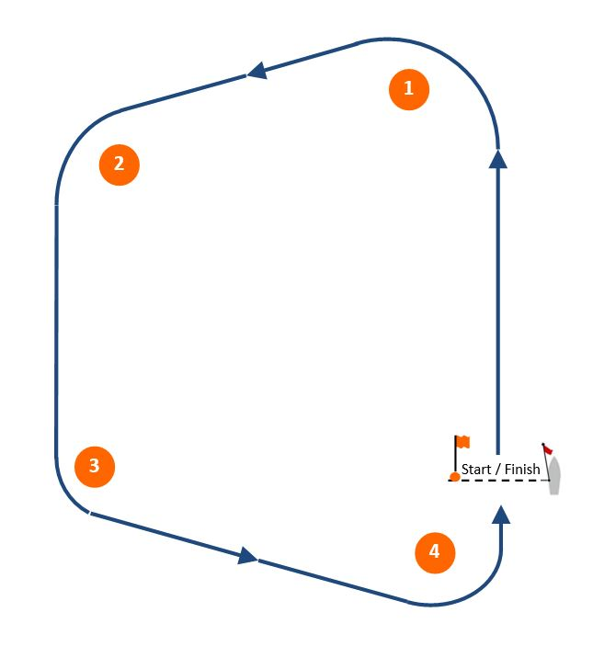

Start and finish line is between committee boat and Dan-buoy with an orange flag.

“d” (course signal: d)
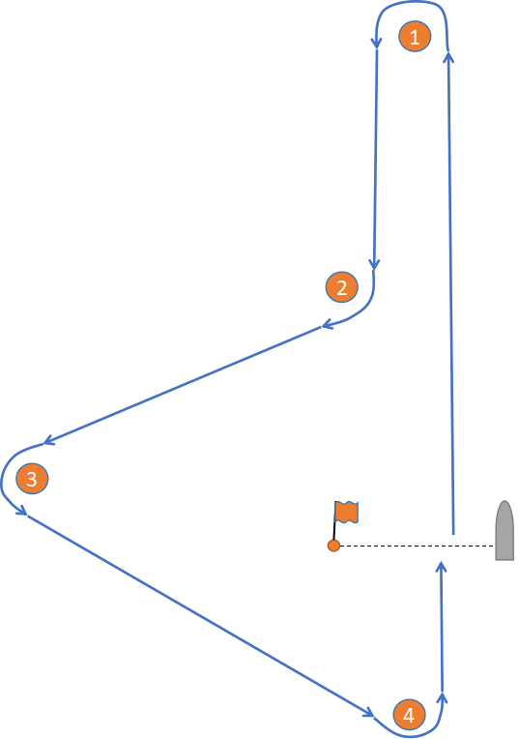
A “d” course with one side in a windward direction.
Marks will be inflatable pillar buoys
Marks shall be rounded as follows -
1 Windward (Port)
2 Off-wind 1 (Starboard)
3 Off-wind 2 (Port)
4 Leeward (Port)
5 Finish Gate
Marks 1-5 constitute 1 lap. Repeat marks 1-5 until finishing signal is made from Committee boat. Boats will be finished when passing through the Finish Gate after rounding Mark 4.

Start and finish line is between committee boat and Dan-buoy with an orange flag.

Windward/Leeward (course signal: W)

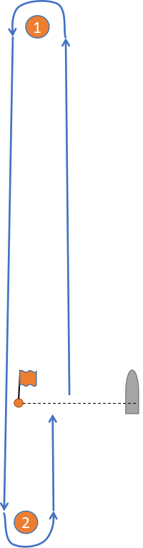
Mark 1 will be a pillar buoy
Mark 2 will be a pillar buoy.
Marks shall be rounded as follows -
1 Windward (Port)
2 Leeward (Port)
3 Finish gate

Marks 1 - 2 - 3 constitute 1 lap. Repeat marks 1 - 3 until shorten course signal is made from Committee boat, then use Finish Gate

Note SI 9.5

Start and finish line is between committee boat and Dan-buoy with an orange flag. Note that the finsh gate may be shortened after the start sequence has completed.

Addendum B- START SEQUENCE

Display | Start Number |  |  |  |  |  |  |  | Display
Display | 1 |  | 2 |  | 3 |  | 4  (1st recall) |  | Display
Display | Means | Time to start (mins) | Means | Time to start (mins) | Means | Time to start (mins) | Means | Time to start (mins) | Display
0 | Warning | 3 |  |  |  |  |  |  | 0
1 | Prep | 2 |  |  |  |  |  |  | 1
2 | One minute | 1 |  |  |  |  |  |  | 2
3 | Start | 0 | Warning | 3 |  |  |  |  | 3
4 |  |  | Prep | 2 |  |  |  |  | 4
5 |  |  | One minute | 1 |  |  |  |  | 5
6 |  |  | Start | 0 | Warning | 3 |  |  | 6
7 |  |  |  |  | Prep | 2 |  |  | 7
8 |  |  |  |  | One minute | 1 |  |  | 8
9 |  |  |  |  | Start | 0 | Warning | 3 | 9
10 |  |  |  |  |  |  | Prep | 2 | 10
11 |  |  |  |  |  |  | One minute | 1 | 11
12 |  |  |  |  |  |  | Start | 0 | 12

