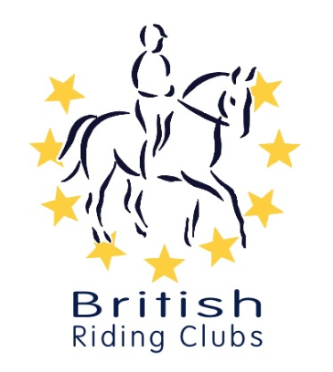
Gipping Riding Society

Spring Dressage Show
Sunday 19th April 2026

By Kind Permission of Caroline Spurrier,
Crows Hall, Debenham, IP14 6NG

Judge – Niki Barker





Entries close Sunday 12th April 2026, times will be published Thursday 16th April 2026.
CLASS | TEST
1 | BD Intro 1 (2024)
2 | BD Intro 2 (2024)
3 | MIXED INTRO PAIRS  BRC Intro Pairs 1 (2022)
4 | PYO BRC Prelim A (2025) of BRC Prelim B (2025)
5 | BD Prelim 1 (2024)
6 | PYO CHAMPS 2026 PRACTICE TEST:  BD Intro 3 (2024), BD Prelim 2 (2024), BD Novice 2 (2024)
7 | BD Novice 1 (2024)
8 | BD Elementary 1 (2024)
9 | BRC MEMBERS ONLY PYO FREESTYLE TO MUSIC (20X60 LONG ARENA):  Prelim FTM (2016), Novice FTM (2019), Elementary FTM (2024)

- Classes priced at £12 for GRS members, £18 for non-members.
- Onsite First Aider all day (£3.50) per competitor.
- Classes 1-8 open to both GRS members and non-members.
- Class 9 due to BRC music licences rules is only open to BRC members.
- Lauren from Foxhall Creative Photography with us all day.
- Shared refreshments table, any donations and contributions appreciated.
- Tests to be ridden on a surface. Warm up on grass.
- Please pick up any droppings and leave the venue tidy.
- Entries to be made via Webcollect here:

