Booking. Webcollect, https://historicaldance.org.uk/coming-events.
BACS: sort code 40-40-24, HDS account 7230 2934, ref Halsway2026 + name/s. Send form to Ann Hinchliffe, thedancingmaster@outlook.com
Or post booking form and cheques (to The Historical Dance Society) to: Ann Hinchliffe, 2a Clifton Grove, Wirral CH44 0BH.
Total cost of room/s £
Your contact details:  Name  Address  Phone/s  Email/s | Emergency contact (mobile number preferred):
Please tell us your special requirements e.g. diet or accessibility. It is helpful for us to know privately if you have any problems that will affect your dancing. Feel free to contact us in confidence to discuss your needs.

Which class would you prefer?

For Sam's class, what level (approximately ) do you play at?

What singing or speaking have you done (optional)?

HDS is a Charitable Incorporated Organisation (1178919)
Website: historicaldance.org.uk FB: HistoricalDanceSociety
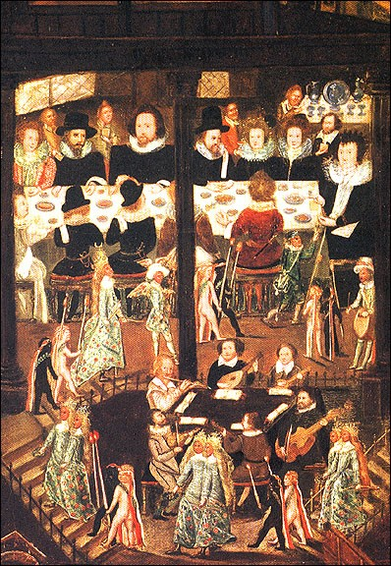
Dance, music and masquing at the court of Elizabeth I
16-18 January 2026
Halsway Manor, near Crowcombe, TA4 4BD

You are invited to a friendly house-party in beautiful West Somerset. The weekend is based on re-creating the Masque of Diana and Actaeon, performed at the court of Elizabeth I. Tutors are Ann Hinchliffe (beginners and improvers), Anne Daye (experienced dancers), and Sam Brown (musicians).
Programme
Friday evening: dancing together and a short talk on the masque and its background of court intrigue. Saturday morning classes: a balletto with Anne and Tudor dances with Ann. Afternoon: re-creating the masque with costume, dancing, music, song and spoken word. Evening: revels as in the Queen's Privy Chamber -- dance, song, poetry and music. Sunday morning: dance practice and rehearsing our version of the masque, which will be performed in the afternoon, ending with a cream tea.
Lutenist Sam Brown will run separate sessions for musicians on music of the time and pieces for the masque. All acoustic instruments are welcome. Pitch: A = 440 hz for the weekend. Scores will be sent in advance; please let us know your level of notation reading.
The masque also has singing and speaking roles for anyone interested. Please tell us your experience.
Travel
Address: Halsway Manor, Halsway Lane, near Crowcombe, Somerset, TA4 4BD, UK. Halsway is just outside Crowcombe village, 11 miles from Taunton, the nearest train station. There are hourly buses on weekdays; weekend services are currently uncertain. Taxi to Taunton station costs about £50. Lifts can sometimes be arranged with other dancers attending the course: contact organiser Ann Hinchliffe, 07780 799 613 or 0151 458 6709 or thedancingmaster@outlook.com.
More information on Halsway website: https://halswaymanor.org.uk/
Accommodation
All bedrooms in Mews building are modern, either en-suite or with private bathroom. Bedrooms in the old Manor have period character but few en-suite facilities, so guests must walk a few steps along the corridor for toilets and showers. Camping options are available including en suite 'glamping pods'.

Food is tasty, plain and plentiful, and all diets can be catered for.

Covid precautions.
HDS and Halsway request people not to attend unless they are sure they are free from Covid. Halsway Manor is accredited 'Good to Go' and requests attenders to support them by following house protocols. The dances include hand-holds: feel free to wear gloves if you wish. Sanitiser will be provided. If the course has to be cancelled by a return of Covid, all money will be refunded.

BOOKING FORM
Ticket prices
Prices per person for whole weekend, Fri evening - Sun afternoon, full board. Circle which rate and write in how many people it includes. Please ask about accommodating part-time visitors, or companions who don't take part in all activities.
 | By 23 Nov  (circle which rate) |  | After 24 Nov  (circle which rate)
 | HDS member | Non-member | HDS member | Non-member
Single  en-suite | £395 | £405 | £405 | £415
Single, shared bathroom | £353 | £363 | £363 | £373
Shared room,  en-suite | £353 | £363 | £363 | £373
Shared room, shared bathroom | £315 | £325 | £325 | £335
Non-resident, own tent or caravan: £268; +£10 non-member, + £10 after 24 Nov. Glamping pods: prices as for en-suite, above.

