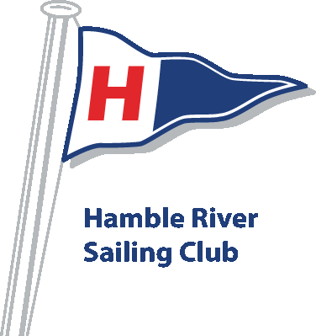
Hamble River Sailing Club
The Ferry Hard
Hamble
Southampton
SO31 4J
023 8045 2070

Student Medical Form
Name Date of Birth
Age Address 1
Address 2
Post Code Telephone Mobile
E-mail
Emergency Contact Name Telephone
MEDICAL INFORMATION DECLARATION (CONFIDENTIAL)
Please give the following information so that your child can be properly supervised in the care of the Club and also, in the unlikely event of an accident, correct treatment can be given. Please note: it is your responsibility to inform the Club/Chief Instructor of any changes to your medical conditions.
Do you receive treatment for any of the following conditions? (please tick) YES / NO
Asthma, Bronchitis, Heart Condition, Fits, Black Outs, Fainting, Severe Headaches, Diabetes or Travel Sickness.

Is your child known to be are you allergic to any of the following: drugs, medicines, materials, foods, plasters, other allergies?

Does your child have a disability, learning difficulty or medical condition which may affect your learning?

Is your child receiving medical or surgical treatment from your family doctor or hospital or have you been given specific medical advice to be followed in an emergency?

Has your Child been vaccinated against TETANUS in the last 10 years?

IF THE ANSWER TO ANY QUESTION ABOVE IS YES, please give information regarding care, treatment and medication that you wish the Club staff to observe (continue overleaf if necessary).

Consent for taking images
During the course we may take pictures and videos for use in presentations, displays or in our own booklets, newsletters or publicity. In the event of any images being taken, I consent to them being used for promotional or educational purposes.
Please note that our website can be viewed throughout the world and not just in Britain where British law applies.

DECLARATION
I have completed the medical declaration and I consider that my child is fit and capable of taking part in the activities organised by the Club. I accept that water sports can at times be hazardous, and confirm that I will not hold club instructors or officers responsible for any injury, damage or loss suffered whilst engaged in club activities.

My child CAN swim confidently or CAN swim 25m / 50m wearing a buoyancy aid or CANNOT swim

In the event of illness or an accident, I consent to any necessary medical treatment,
Printed name Signed Dated
Person with parental responsibility

