Blaze Eastern Championships

13th & 14th May 2023

Isle of Sheppey Sailing Club

Sailing Instructions
Version 2 – Updated 05/05/23

The Organising Authority is the Isle of Sheppey Sailing Club in association with the Blaze Class Association to which all competitors must be members.

- RULES
  - The Regatta will be governed by the Racing Rules of Sailing
  - The Blaze Class rules also apply.
  - RYA prescriptions
  - Where there is conflict between the NOR and these SI the SI will prevail. This changes
RRS 63.7
  - The RYA Racing Charter will apply

2. NOTICES TO COMPETITORS
Notices to Competitors will be posted on the Official Notice Board located opposite the main bar of the Sailing Club
There is a briefing scheduled for 1030 on Saturday 13th in the main hall.

3.CHANGES TO SAILING INSTRUCTIONS
Any change to the Sailing Instructions will be posted before 0900 on the day it will take effect, except that any changes to the schedule of races will be posted by 2000 on the day before it will take effect.

4. SIGNALS MADE ASHORE
4.1 Signals made ashore will be displayed on the main Flagstaff at the IOSSC Main Mast
4.2 When flag AP is displayed ashore “1minute” will be replaced with “not less than 30 minutes” in the race signal AP.

5.SCHEDULE OF RACES
13th May - Races 1, 2 & 3
14th May - Races 4, 5 & 6

5.1 The scheduled time of the warning signal for the first race on Saturday 13th May is 1155.
5.2 The scheduled time of the first warning signal for races on Sunday 14th May is 1025
5.4 There will be no warning signal after 1355 on Sunday 14th May.
5.5 An orange attention signal will be displayed on the committee vessel no less than 5 minutes before the warning signal of the first scheduled start sequence of each day. If there is a significant delay between races the Orange Signal may be removed and then displayed to signify a new sequence is about to begin.

6. CLASS FLAG
The Class flag for the Blaze class will be the international code of signals flag BRAVO (B) or the class flag supplied by the association.

7. RACING AREA
The racing area will be in the Thames Estuary.

8. COURSES
The Courses to be sailed are described in Addendum A, and will be displayed on the Committee Vessel along with an approximate compass bearing to the first mark.

9. MARKS
If Course A or B is used:
The Windward will be a tall orange cylinder buoy
The Spreader will be a pink pebble buoy (if Applicable).
The Wing mark (if Applicable) will be a short orange cylinder buoy.
The Leeward mark or Gate (if Applicable) will be orange pyramid buoys.

If Course C is used:
The Windward (W) and Leeward (L) buoys will be Orange Cylinder Buoys.
The Outer Windward (A) and the Outer Leeward (B) buoys will be Orange Pyramid Buoys.

The Pin end of the start line will be a dan buoy with orange flag
The Outer finish mark will be dan buoy with Blue flag.

10. THE START
10.1 An Orange Flag will be displayed on the Committee Vessel not less than 5minutes before the warning signal when it is on Station.
The Starting Line will be between the main mast on the Committee Vessel at the starboard end, and the course side of the port end starting mark.
10.2 Any boat making contact with the Committee Boat will be scored DSQ without a hearing, this changes Rule 63.1 and A5.
10.3 A boat that does not start within 3 minutes of her starting signal will be scored DNS. This changes RRS Appendix A4
10.4 The starting sequence will be 5, 4, 1, Go, with the appropriate flags.

11. CHANGE OF THE NEXT LEG OF THE COURSE
11.1 Minor mark moves (up to approximately 150m) may be made without signalling the change. This changes RRS 33

12. THE FINISH
12.1 A Blue flag will be displayed on the Committee Vessel.
12.1.1 When finishing the Courses A or B, the finishing line will be between the main mast on the Committee Vessel and a nearby finishing mark with a blue flag.
12.1.2 When finishing Course C, the finish will be between the committee boat and the start line pin with an orange flag

13. TIME LIMITS
13.1 If no boat has passed Mark 1 within 30 minutes of the Start the race may be abandoned.
13.2 The Time Limit for the first boat in each race will be 60 minutes.
13.3 The Target time for races will be 35/40 minutes for the first boat. Failure to meet the target time will not be grounds for redress. This changes RRS 62.1(a)

13.4 WHISKEY FLAG
After the first boat has finished, and 15 minutes has elapsed flag W may be displayed with two sound signals. Any boats still on the course who have not retired or been UFD or BFD shall be given their place, as judged by the Race Committee, on the course and return to the Starting area.

14. ABANDONING A RACE
14.1 Under Rule 32.1 the Race Committee may abandon a race because of a major wind shift, irregular winds or when the wind speed drops below 6 knots, as measured by the Race Committee. Any action or no action taken by the Race Committee will not be grounds for redress under RRS 60.1b

15. PROTESTS AND REQUESTS FOR REDRESS
15.1 Protest forms are available from the IOSSC main hall. Protests and requests for redress or reopening shall be delivered within the appropriate time limit.
15.2 The Protest time limit is 60 minutes after the last boat has finished the last race of the day or the Race committee has signalled no more racing today whichever is the sooner.
15.3 Notices will be posted no later than 30 minutes after the protest time limit to inform competitors in which they are parties or named as witnesses. Hearings will be held in a place to be advised.
15.4 Notices of protests by the Race Committee or Protest Committee will be posted to inform boats under RRS 61.1(b)
15.5 On the last scheduled day of racing a request for reopening shall be delivered
a) within the protest time limit if the requesting party was informed of the decision on the previous day.
b) No later than 30 minutes after the requesting party was informed of the decision on that day.

15.6 On the last scheduled day of racing a request for redress based on a Race committee decision shall be delivered no later than 30 minutes after the decision was posted. This changes RRS 62.2.

16. SCORING
16.1. A minimum of 3 races will constitute the series.
16.2. If 3 or fewer races have been completed a boats score shall be the total of her race scores
16.3. If 4 or more races have been completed a boats score shall be the total of her race scores excluding her one worst score.
16.4 To request an alleged error in the posted race results a boat shall complete an enquiry form available from the office.
16.5 A boat that is recorded DNC, DNS, UFD, BFD or DSQ shall be scored points for one more than the number of boats entered in the series. A boat that is recorded RET, DNF or OCS will be scored for one more than the number of boats that started in that race. This changes RRS A4.2

17. EQUIPMENT AND MEASUREMENT CHECKS.
17. 1 A boat or equipment may be inspected at any time for compliance with the Blaze class rules and sailing instructions. On the water, a boat can be instructed by a race committee equipment inspector or measurer to proceed immediately to a designated area for inspection.
17. 2 non-electrical compasses are permitted.
17.3 Electronic equipment:
Electronic compasses are permitted.
Timing devices are permitted.
A timing device and electronic compass may be integrated in the same device.
A Compass or timing device must not be capable of displaying, delivering, transmitting, receiving, calculating, correlating, or storing information about wind speed, wind direction, boat speed or boat position.
A single GPS tracker is permitted provided that data cannot be viewed by the sailor during racing.
Any use of electronic equipment not specifically allowed in the above instructions are prohibited.

18. EVENT ADVERTISING
Boats may display advertising.

19. SUPPORT BOATS.
Support boats are not permitted in the sailing area.

20. TRASH DISPOSAL
Trash may be placed aboard a Committee Vessel as long as it is contained in a suitable
Bag and sealed. The penalty for a breach of RRS55 may be less than DSQ at the discretion of the Protest Committee.

21. RADIO COMMUNICATION
21.1 Except in emergency a boat shall neither make nor receive voice or data transmissions that are not available to all boats. This applies also to mobile phones.
21.2 Data and information from Cameras, video and positioning equipment shall not be admissible in protests or be grounds for redress.

22. PRIZES
Prizes and trophies will be awarded at the discretion of the Class Association

23. RISK STATEMENT
RRS 4 states: “The responsibility for a boat’s decision to participate in a race or to continue racing is hers alone.” Sailing is by its nature an unpredictable sport and therefore inherently involves an element of risk. By taking part in this series, each competitor agrees and acknowledges that:
a. They are aware of the inherent element of risk involved in the sport and accept responsibility for the exposure of themselves and their boat to such inherent risk whilst taking part in the series;
b. They are responsible for the safety of themselves, their boat and their other property whether afloat or ashore;
c. They accept responsibility for any injury, damage or loss, to the extent caused by their own actions or omissions;
d. Their boat is in good order, equipped to sail in the series and they are fit to participate;
e. The provision of a race management team, other officials and volunteers by the event organiser does not relieve them of their own (the competitors’) responsibilities.

24. TALLIES

A Tally system will be in place for the event.
Tallies must be collected from the Tally Board and placed in the box ‘I have started’ before launching and must be placed in the appropriate box no later than 30 minutes after returned from racing. It is the sole responsibility of competitors to ensure that they have tallied correctly.
Failing to comply, will result in a penalty of a £5 fine being applied. All fines received will be donated to the RNLI.

26. For further information please look at either the Blaze Class Association or IOSSC Websites.

ADDENDUM A The Course

Course A
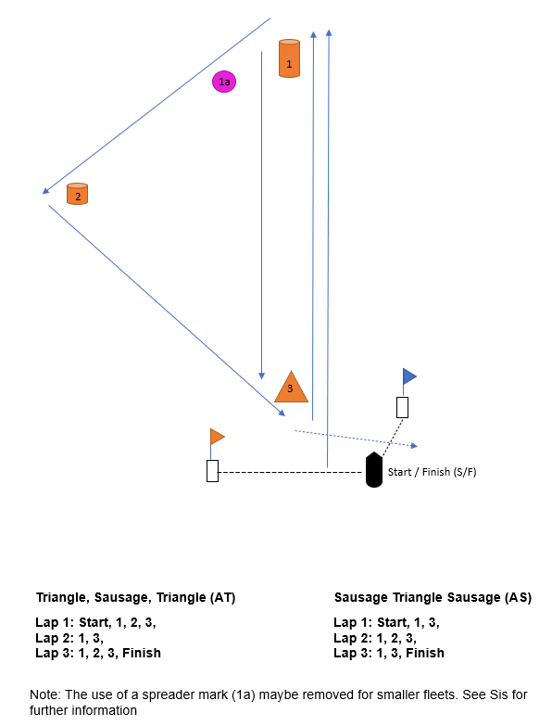

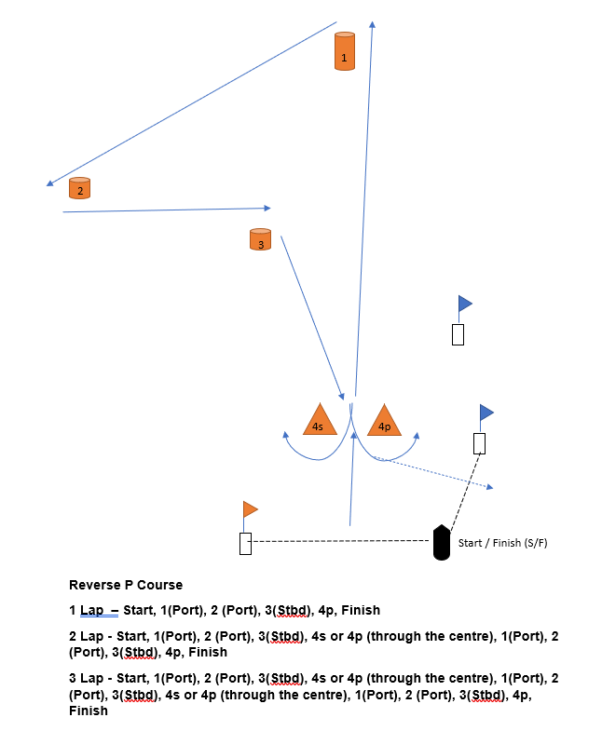
Course B

Course C
A
B
L
W

Start / Finish (S/F)

Trapezoid Course

Laps = S/F, W(port), A(port), B(port), L(port), S/F

Number of laps = As required by the PRO.
Note: Pass through S/F on every lap

