RYA SI Course
The following information should answer most of your pre-course questions, but if you require further advice then please contact me Edward-curtis@outlook.com and/or nicwymer@gmail.com
The Senior Instructor (SI) is an experienced instructor who has been assessed as competent to organise and manage courses within the RYA’s Sailing Scheme. The 4-day course covers the role of the Senior Instructor, including centre management, on water management and delivery of on water sessions. At an RYA Recognised Centre the Chief Instructor for sailing needs to be a qualified Senior Instructor.
The course should be an enjoyable opportunity to share ideas, discuss issues with plenty of learning. It will be led by two trainers whose main role is to facilitate the course and gather the evidence that the candidates have the ability to fulfil the role. Should the outcome not be a straight pass we will ensure that you are aware as you go through the course of any areas you may need to develop and we will ensure that the route to gaining the award is as SMART as possible.
Pre-entry Requirements
• In order to become a Senior instructor, candidates need to fulfil the following requirements as follows;
• Demonstrate sailing ability under the supervision of an RYA trainer as detailed in G14 (Pre-entry test). This is the same sailing ability that was required for the Dinghy Instructor course.
• Have sufficient experience as a Dinghy Instructor prior to the course. This is generally attained as an RYA Dinghy Instructor. Knowledge of the RYA and the RYA Sailing Schemes must be demonstrated prior to the course.
• Pass the RYA Safety Boat Course
• Complete the RYA “Safe and Fun” course and bring your Course Completion reference code with you. If you have already completed this for a previous course then bring the reference code with you.
• Completion of the RYA Senior Instructor Workbook.
• For the award to be valid you must have a current and suitable first aid qualification as set out on the RYA website.
- Signed recommendation from CI, Principal or RDO

COURSE INFORMATION

Pre-course work

RYA Senior Instructor Workbook.

Completing the workbook will draw on your experience as an instructor along with you logistical and technical abilities. There are many areas where the answers are neither right nor wrong and will reflect the environment that you have experienced. We will spend some time during the course looking at the workbook but it is designed to save time on the course so we will limit this to the areas where you have questions. To download the workbook, please use the link on the last page, found below.

You should also take this opportunity to familiarise yourself with both the National Sailing Scheme and the Youth Scheme as well as the sections on learning and teaching in G14.

PRACTICE SAILING A VARIETY OF DINGHIES

It is not expected for instructors or Senior Instructors to be ‘world class’ in every type of dinghy but it is expected that they have enough ability to run sessions on their use. Simple single-handers (Toppers/Picos etc) and simple crewed dinghies are the mainstay of the training craft used. Some experience with the junior classes is very useful.

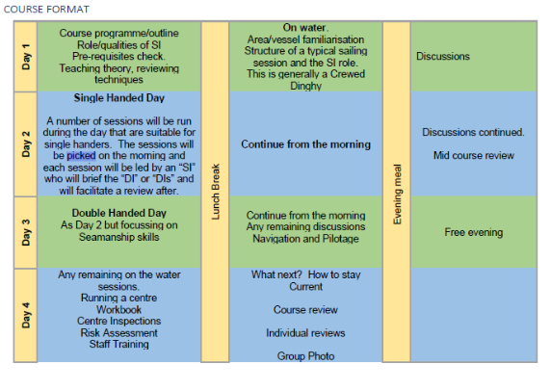
WHAT TO BRING WITH YOU
RYA publications;
G14 (INSTRUCTORS HANDBOOK)
G4 (NATIONAL SAILING SCHEME LOGBOOK)
G11 (YOUNG SAILORS LOGBOOK )if you have a copy.
Paper, pens, waterproof notebook, Whistle
Your S&F code, your Safety Boat Cert
RYA MEMBERSHIP
You will need to be a current member of the RYA when you either gain a new award or revalidate an existing award. Most RYA instructor awards need revalidating every 5 years. Gaining the Dinghy SI will revalidate all your existing sailing instructor awards (Racing, Multihull, Keelboat, Advanced, Foiling) for a further 5 years.

Sailing Sessions
The Single Handed sessions will be chosen from the following;
• Improving tacking
• Improving gybing
• Sailing Backwards
• Rounding a windward Buoy (Racing)
• Starts (Racing)
• Covering (Racing)
• Sailing with no Centreboard
• Speed Control (FML)
• Sailing with a tethered rudder
• Launching and landing on a lee shore

The Double Handed sessions will be chosen from the following;

• Improving tacking
• Improving gybing
• Hoisting and dropping the spinnaker
• Gybing the spinnaker
• Man Over Board
• Coming Along Side a moored boat
• Sailing with a tethered rudder
• Picking up a mooring
• Launching and landing on a lee shore
• Sailing on Jib alone

Discussions

Each Candidate will chair a discussion lasting approximately 20 minutes. During the discussion they will use various techniques to facilitate the group to discuss various issues. The Chair will ensure everyone is involved and collect the outcome of the discussion in some way that can be recorded (written on a whiteboard etc)

The discussions will be allocated on the first day of the course and will be drawn from the following list;

• Poor weather alternatives
• Keeping instructors inspired and enthusiastic
• Dealing with a group where the ability of the sailors ranges widely
• Dealing with an unhappy customer
• Preparing for an inspection
• Purchasing boats
• Maintaining equipment
• Inclusivity and Diversity, who is sailing for?
• Sailability and teaching sailors with special requirements.
• Assistant instructors
• Designing course programmes
• Induction of a new instructor to you centre.

Teaching and Discussion techniques that you can use

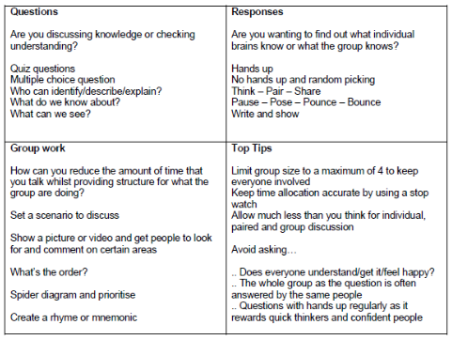

Prior reading
You need to complete the SI workbook prior to coming on the course, please bring a copy of this with you, it is perfectly fine to save a few trees and doing this in electronic format. The Si workbook can be found here.
https://www.rya.org.uk/training-support/Documents/SI_workbook_dinghy.pdf
Also these links will take you to so information on the RYA website that you may find useful to familiarise yourself with
https://www.rya.org.uk/courses-training/courses/dinghy-multi-keel/Pages/hub.aspx
https://www.rya.org.uk/knowledge-advice/safe-boating/look-after-yourself/Pages/hub.aspx
https://www.rya.org.uk/knowledge-advice/safe-boating/look-after-yourself/Pages/cold-water-shock.aspx
https://www.rya.org.uk/knowledge-advice/safe-boating/look-after-yourself/Pages/Concussion.aspx
https://www.rya.org.uk/training-support/Pages/wavelength.aspx

