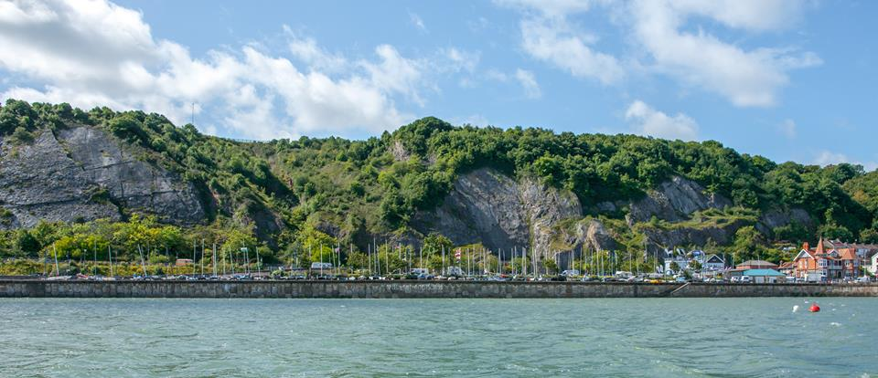


B14 National Championships and Dart 18 TT 9
29th – 31st August 2025
Mumbles Yacht Club, Swansea

SAILING INSTRUCTIONS
- RULES
  - The event is governed by the rules as defined in The Racing Rules of Sailing 2025-2028, prescriptions of the RYA, the rules of the B14 Class Association for the B14 class, the rules of UKIDA for the Dart 18 class, the Notice of Race and these Sailing Instructions.
  - Rule 40.1 applies whilst afloat.
- COMMUNICATIONS WITH COMPETITORS
  - Notices to competitors will be posted on the official notice board located online at https://mumblesyachtclub.co.uk/index.php/official-notice-board/.
  - Notices to competitors and other updates may also be repeated on the event WhatsApp Group and in the foyer of the Club on the physical noticeboard or a flip chart. Should this information differ from the Official Notice Board online (see SI 2.1) then the Official Notice Board takes precedence. The Race Committee will provide updates regarding postponements and other useful information using the event WhatsApp group.
  - Use the link below to join the event WhatsApp group will be provided at registration. Failure to receive WhatsApp messages shall not be grounds for redress and changes RRS62.1(a)
https://chat.whatsapp.com/D40peQNMREo3JROwCfooDQ
  - There is an event page for the B14s at https://mumblesyachtclub.co.uk/index.php/B14-national-championships-2025/ which holds links to the official notice board and the race documents.
  - There is an event page for the Dart 18s at https://mumblesyachtclub.co.uk/index.php/dart-18-tt-9/ which holds links to the official notice board and the race documents.
  - The race office is located on the left-hand side of the foyer in Mumbles Yacht Club.
  - Briefings will be held on the first floor of the Clubhouse at 1000 on the first day of racing (Friday for the B14 class, and Saturday for the Dart 18 class).
  - While racing, except in an emergency, a boat shall not make voice or data transmissions and shall not receive voice or data communication that is not available to all boats.
  - Any change to the sailing instructions will be posted no later than an hour before the start of the first race of the day, except that any change to the schedule of races will be posted by 2000 on the day before it will take effect.
- SIGNALS MADE ASHORE
  - Signals made ashore will be displayed on the flagpole on the roof of Mumbles Yacht Club.
  - When flag AP is displayed ashore, ‘1 minute’ is replaced with ‘not less than 45 minutes’ in Race Signals AP.
- SCHEDULE OF RACES
  - A total of 9 races (three races each day) will be scheduled for the B14 class.
  - A total of 6 races (three races each day) will be scheduled for the Dart 18 class.
  - Racing will follow the schedule below.
Day | Start Time | Warning Signal | Number of races | High Water
Friday 29th August (B14 Only) | 1130hrs | 1125hrs | 3 | 10:25 @ 8.30m
Saturday 30th August | 1130hrs | 1125hrs | 3 | 10:54 @ 7.82m
Sunday 31st August | 1030hrs | 1025hrs | 3 | 11:30 @ 7.30m

  - Following races as soon as possible.
  - One extra race per day may be sailed, provided that not more than one race ahead of schedule and the change is made according to SI 2.7.
  - The Dart 18 start sequence will commence close to immediately after the successful B14 start and the start line is deemed clear by the Race Committee.
  - To alert boats that a race or sequence of races will begin soon, the orange starting line flag will be displayed with one sound at least one minute before a warning signal is made.
  - On the last scheduled day of racing, no warning signal will be made after 1430hrs unless by General Recall.
- CLASS FLAGS
  - The class flag for the B14 class will be International Code Flag B.
  - The class flag for the Dart 18 class will be International Code Flag D.
- RACING AREA
  - The racing area is within the confines of Swansea Bay, shown in Addendum B.
- COURSES
  - The diagrams in SI Addendum 1 show the courses including the order in which marks are to be passed, and the side on which each mark is to be left.
  - The course will be 3 laps (LRA3).
- MARKS
  - Marks 1, 4s and 4p will be orange cylindrical marks.
  - Mark 1a will be a thin yellow cylindrical mark
  - New marks, as provided in SI 11, are orange cylindrical marks with a white band around.
- OBSTRUCTIONS
  - The following object is designated as an obstruction:
  - Mumbles Pier
- THE START
  - The start line will be between a staff flying an orange flag on a race committee boat at the starboard end and the starting mark at the port end.
  - Boats whose warning signal has not been made shall avoid the starting area during the starting sequence for other races.
  - The starting mark will be a large yellow cylindrical mark.
  - A boat that does not start within 5 minutes after her starting signal will be scored Did Not Start without a hearing. This changes RRS A4 and A5.
- CHANGE OF THE NEXT LEG OF THE COURSE
  - To change the next leg of the course, the race committee will lay a new mark (alternate windward mark) and remove the original mark as soon as practicable. When in a subsequent change a new mark is replaced, it will be replaced by an original mark.
- THE FINISH
  - The finishing line will be between a staff flying a blue flag on a race committee boat and the finishing mark.
  - The finishing mark will be a thin yellow pin mark.
  - The race committee may award a finishing place to a boat by pointing Flag W at her with a sound. The signalled boat shall be deemed to have finished, and the score awarded shall be the position she occupied at the time of the signal. If two or more overlapped boats are signalled, they shall be scored as if they were tied. This changes RRS 28.1 and A3.
- PENALTY SYSTEM
  - RRS 44.1 is changed so that the Two-Turns Penalty is replaced by the One-Turn Penalty.
  - When an incident occurs where a penalty applies while the head of the spinnaker is above the main-boom gooseneck, the penalty may be taken immediately after the next time the head of the spinnaker is lowered below the main-boom gooseneck but shall always be taken prior to rounding the next mark or crossing the finish line. This changes RRS 44.2 (only applicable to B14 Class)
- TIME LIMITS
  - The Mark 1 Time Limit, Race Time Limit (see RRS 35), and the Finishing Window are shown in the table below.
Class | Target Time | Mark 1 Time Limit | Race Time Limit | Finishing Window
B14 | 45 minutes | 20 minutes | 90 minutes | 20 minutes
Dart 18 | 45 minutes | 20 minutes | 90 minutes | 20 minutes

  - If no boat has passed the first mark within the Mark 1 Time Limit, the race will be abandoned.
  - The Finishing Window is the time for boats to finish after the first boat sails the course and finishes. Boats failing to finish within the Finishing Window, will be scored DNF without a hearing, unless SI 12.3 applies. This changes RRS 35, A5.1 and A5.2.
  - Failure to meet the Target Time will not be grounds for redress. This changes RRS 62.1(a).
- HEARING REQUESTS
  - The protest time limit is 60 minutes after the last boat finishes the last race of the day or the race committee signals no more racing today, whichever is later. The time will be posted on the official noticeboard.
  - Hearing request forms are available from the race office or the bar, located on the first floor of the Clubhouse.
  - Notices will be posted no later than 30 minutes after the protest time limit to inform competitors of hearings in which they are parties or named as witnesses. Hearings will be held in the race office or the training room located on the ground floor of the Clubhouse beyond.
- SCORING
  - Three races are required to be completed to constitute the B14 National Championship.
  - One race is required to be completed to constitute the Dart 18 TT Championship.
  - Scoring for the B14 class will be as follows:
  - When fewer than six races have been completed, a boat’s series score will be the total of her races scores.
  - When from six to eight races have been completed, a boat’s series score will be the total of her race scores excluding her worst score.
  - When nine races are completed, a boats series score will be the total of her race scores excluding her two of her worst scores
  - Scoring for the Dart 18 class will be as follows:
  - When less than 4 races have been completed, a boat’s score will be the total of her race scores.
  - When 4 or more races have been completed, a boat’s score will be the total of her race scores excluding her worst score.
  - To request correction of an alleged error in posted race or series results, a boat may complete a scoring enquiry form available at the race office.
  - B14 finishing positions will be calculated using the following handicaps:
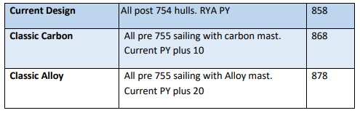
- SAFETY REGULATIONS
  - A tally system will operate; each boat being allocated a tally number which will be posted on the Official Notice board.
  - Any boats that fail to comply with the safety/tally system will be required to make a £10 donation to the RNLI or face disqualification from the race or races concerned.
- REPLACEMENT OF CREW OR EQUIPMENT
  - Substitution of competitors is not allowed without prior written approval of the race committee.
- EQUIPMENT AND MEASUREMENT CHECKS
  - A boat or equipment may be inspected at any time for compliance with the class rules, notice of race and sailing instructions.
- TRASH DISPOSAL
  - Trash may be placed aboard official vessels.
- PRIZES
  - Prizes will be awarded to the first 3 positions in the B14 class.
  - Prizes will be awarded to the first 3 positions in the Dart 18 class.
  - Prizes will be awarded to the first 3 positions in the Dart 18 class based on the UKIDA handicap system.
  - Spot prizes may be awarded at the discretion of the Race Committee or Organising Authority.
- RISK STATEMENT
  - RRS 3 states: ‘The responsibility for a boat’s decision to participate in a race or to continue to race is hers alone.’ By participating in this event each competitor agrees and acknowledges that sailing is a potentially dangerous activity with inherent risks. These risks include strong winds and rough seas, sudden changes in weather, failure of equipment, boat handling errors, poor seamanship by other boats, loss of balance on an unstable platform and fatigue resulting in increased risk of injury. Inherent in the sport of sailing is the risk of permanent, catastrophic injury or death by drowning, trauma, hypothermia or other causes.
  - A boat is entirely responsible for her own safety, whether afloat or ashore, and nothing, whether in the Notice of Race or Sailing Instructions or anywhere else, reduces this responsibility.
  - It is for the boat to decide whether she is fit to sail in the conditions in which she will find herself. By launching, the boat confirms that she is fit for those conditions, and her crew is competent to sail and compete in them.
  - Nothing done by the organisers can reduce the responsibility of the boat nor will it make the organisers responsible for any loss, damage, death or personal injury, however it may have occurred, as a result of the boat taking part in the racing. The organisers encompass everyone helping to run the race and the event, and include the Organising Authority, the Race Committee, the race officer, patrol boats and beach masters
  - The provision of patrol boats does not relieve the boat of her responsibilities.
  - Furthermore, parents or guardians of competitors under 18 yrs will be required to take full responsibility for their dependents throughout the event and to sign the parental declaration on the entry form. The person accepting this responsibility shall be present for the duration of the Championship.
- INSURANCE
  - Each participating boat shall be insured with valid third-party liability insurance with a minimum cover of £3,000,000 per incident or the equivalent.

Addendum A - Courses
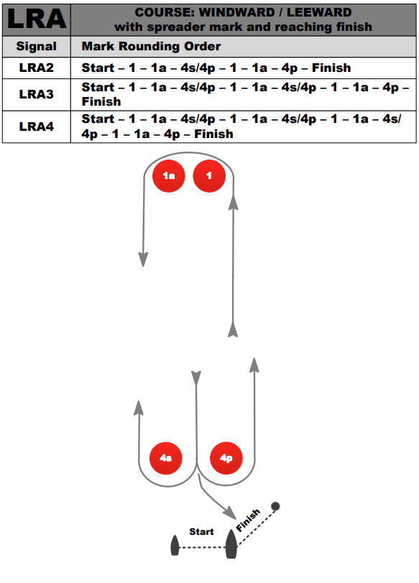

Addendum B - Approximate sailing area

