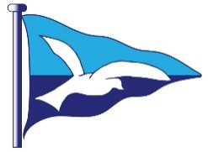
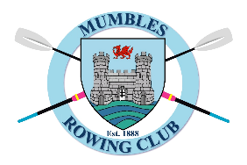

MUMBLES South League Race
Sunday 10th May 2026

- Registration: 08.00am – 9.30am.
- Coxes Briefing: 9.45 am
- First Race: 10.30am – Water Start (start line is 5 minutes from slip)
- Race Order: Ladies, Seniors, Juniors/Novices, Mixed Race
- Sculls welcome
- Race Distance; 3.5miles (2miles for Novice /Junior)
- Fees £10 Adults / Juniors £5

Provisional Race Decision: Saturday 9th May, 6.00pm
Final Race Decision: Sunday, 6.30am and will be posted on Mumbles Rowing Club facebook page https://www.facebook.com/mumblesrowing

Phone/message Stewart for any queries 07957470310
On the day LW 06.32am 6.24m; HW 12.52pm 9.87 m

The galley in club will be open to purchase breakfast rolls, Tea and Coffee.
Food included for competitors to be served after all races are completed.
The bar at the club will be well stocked

PLEASE EMAIL mumblessearowing@outlook.com BEFORE 10pm ON TUESDAY 5th MAY WITH CREW & CLUB REG FORMS. PLEASE STATE ANY DIETARY REQUIREMENTS – VEGGIE, VEGAN, ALLERGIES. (Earlier entries appreciated)

Boat Arrival & Trailer Parking: ; Boats offloaded by Knab Rock slipway and trailer can be left on boat parking. Just3words (players.partners.shampoos) – see map
- Car parking : Knab Rock car park, SA3 4EL – MIPermit app can be used to pay
- Overflow car parking and boat parking 600m away at The Apple carpark(plays.certainly.providing) and The Lighthouse Bar at Bracelet Bay (formally.rises.pythons), in case Knab Rock car park is full.

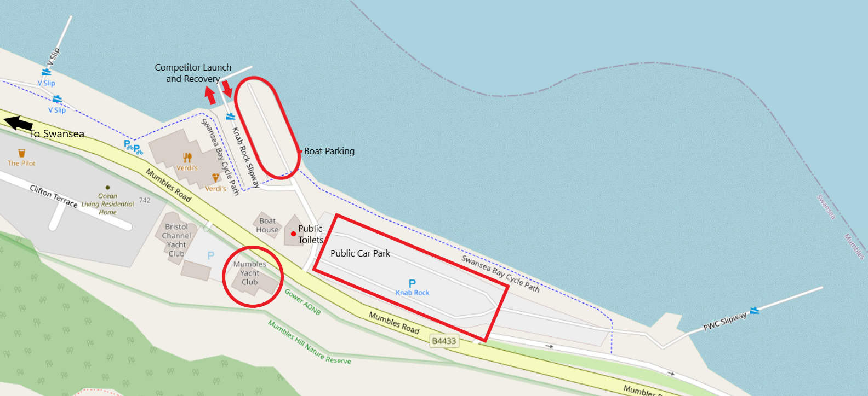

Photographs for promotional purposes will be taken. Let us know if you do not want your picture to be used.
Please bring a working VHF radio. Wearing lifejackets advised for all participants and required for coxes and U18 rowers.
The races will be run under the WSR Racing Rules.
Looking forward to seeing you all!
Mumbles Yacht Club
746 Mumbles Road
Swansea SA3 4EL

