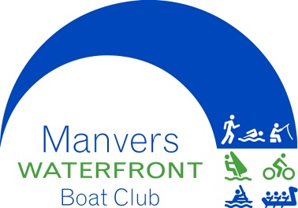


Dearne Valley 10K
Race Instructions
Manvers Waterfront Boat club, Station Road, Manvers Way, Wath-upon-Dearne, South Yorkshire
Sunday May 17th 2026
Main Race Start-9:30am Fun Run Starts-11:30am
Dear Competitor,
Thank you for your entry in the above event. Please check out our Facebook page (5) Dearne Valley 10K | Wath upon Dearne | Facebook for up-to-date information.
Please note that transfers or refunds will not be processed within one month of the race.
Please note the following points:
- Sat Navs will not get you to the venue car park use S63 7BU then follow the map below.
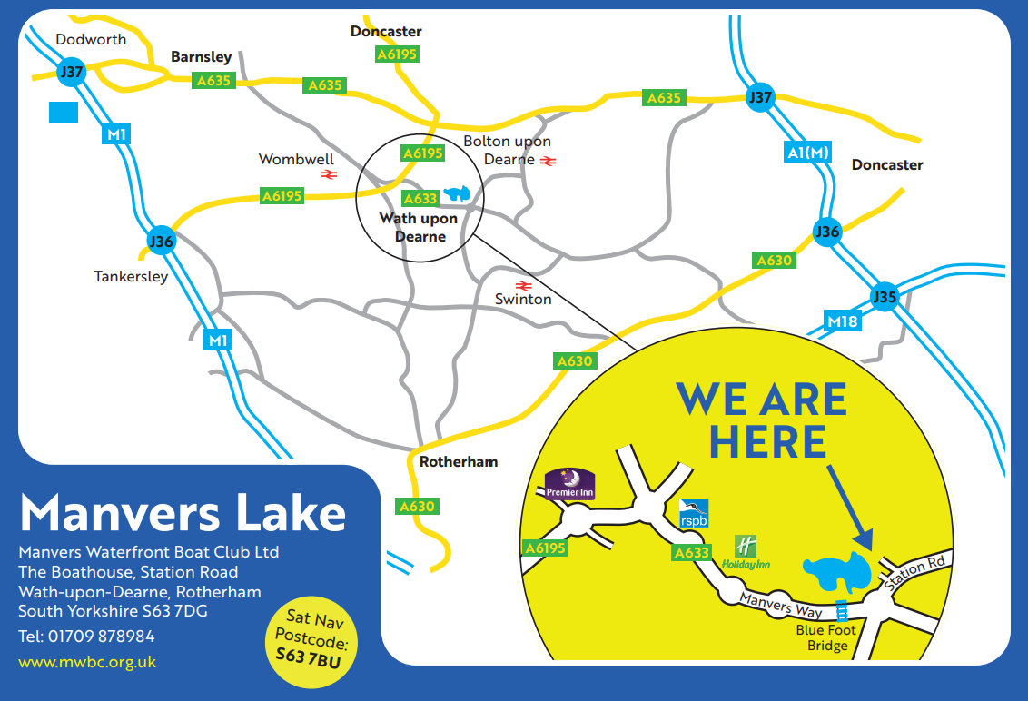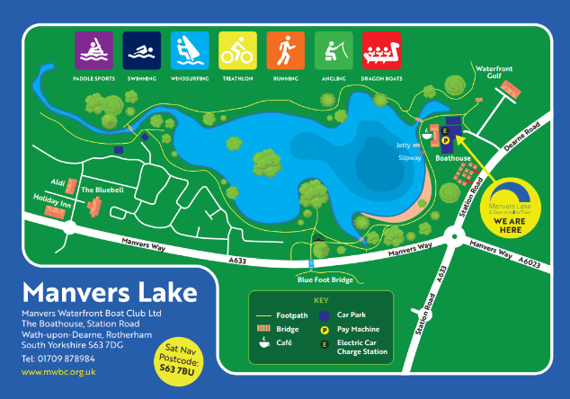
1.Directions. 10 minutes from the M1 at Junction 36 or 15 minutes from the A1(M) at Junction 37.
- From the M1 Junction 36. Head North East on the A6195 along the dual carriageway. Continue along the Dual Carriageway to the end. Go straight on where the A6195 becomes single carriageway. At the next Island turn RIGHT onto the A6023 MANVERS WAY. RSPB Sign on the corner. Go down Manvers Way with the RSPB reserve on your left, then under a blue footbridge. At the next island TURN LEFT into Station Road. Immediately after the housing estate on your left TURN LEFT into the Golf Club entrance. Follow the fence around to the left and the boathouse is straight in front of you.
- From A1(M) Junction 37. Head West along the A635 Barnsley. At the 4th Island (Petrol Station on the corner) TURN LEFT onto the A6195. Follow the road, cross the river Dearne and at next Island TURN LEFT onto the A6023 MANVERS WAY. RSPB sign on the corner. Go down Manvers Way with the RSPB reserve on your left, then under a blue footbridge. At next Island TURN LEFT into Station Road. Immediately after the housing estate on your left TURN LEFT into the Golf Club entrance. Follow the fence around to the left and the boathouse is straight in front of you.

- Registration. You will need to collect your number and confirm your registration on the day. Registration will be open from 8.00am. Please arrive in plenty of time to avoid queues.

- Course Safety. The course is on limestone footpaths paths and roadside footpaths.

- Parking. The majority will be around the southern side of the lake/beach, this is on the run route. If you are leaving early then you may park off the route in the boathouse car park, this will be open from 8:00am and there will be a £3 charge. Event parking is not permitted at the golf club car park. Free parking is available at Wath Cricket Club Wetmoor Lane Wath and walk over the blue bridge to the Boathouse and start.

- Toilets / Showers / Changing and Cafe. These facilities are in the Boathouse.

- Directions to the start. The race starts next to the lake at Manvers Waterfront Boat club car park (see map) just off Station Road, Wath Upon Dearne.

- Food and Drink. A water station is available on the course at approximately 5k and at the finish line.

- Lost property this will be kept at the boathouse for 2 weeks.

- Retirement. Let event control or a Marshal know you are leaving the event/course.

- Useful telephone numbers.

Ruth Wallbank 07783 981467
Emergency Services 999 or 112

We hope you enjoy yourselves and have a good time.
Remember to keep smiling

Dearne Valley 10k - Maps and Instructions
Location Map
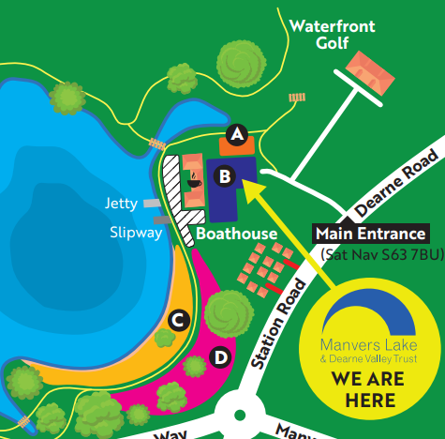
On Site Car Parking is available in car parks, C and D - Note there is a £3 charge for car parking.
Run Route 10K - This may be revised on the day.
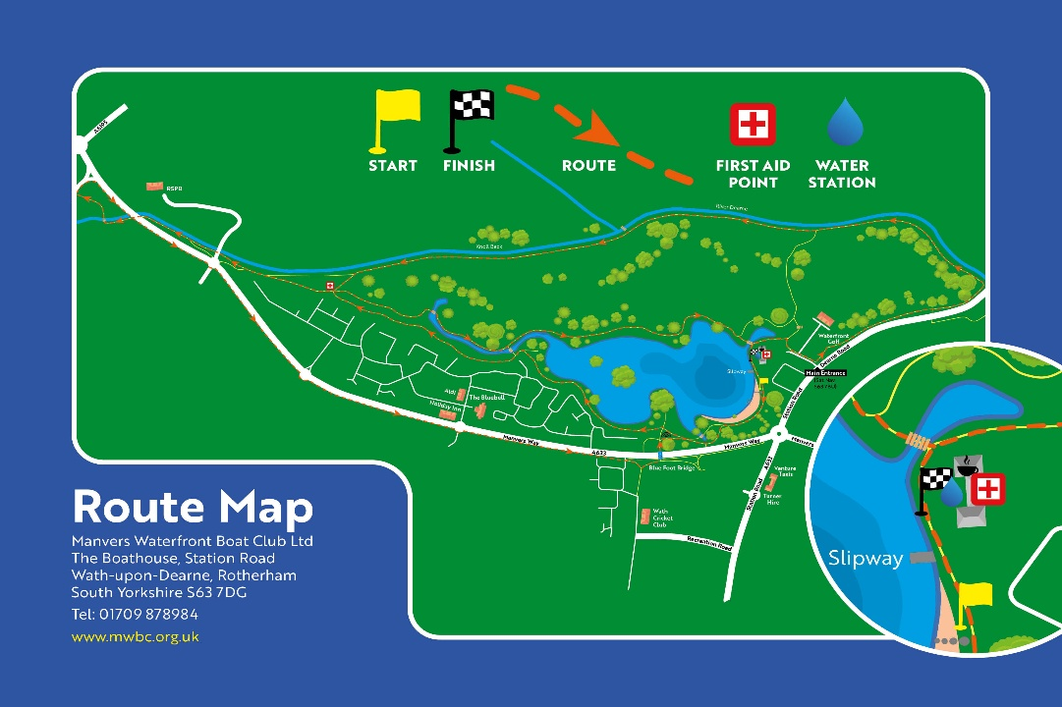

Fun Run Course (anti- clockwise) one lap
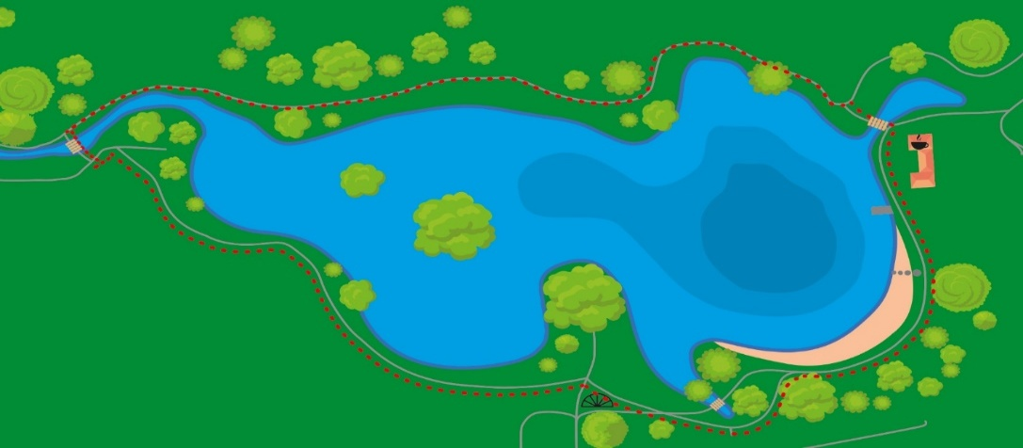
If you have any comments or suggestions for improving the race, please email them to Gavin.king@mwbc.org.uk

