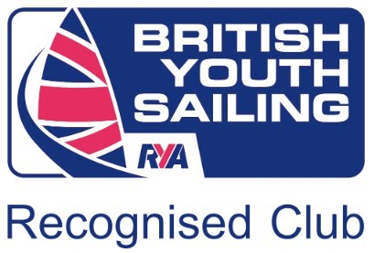
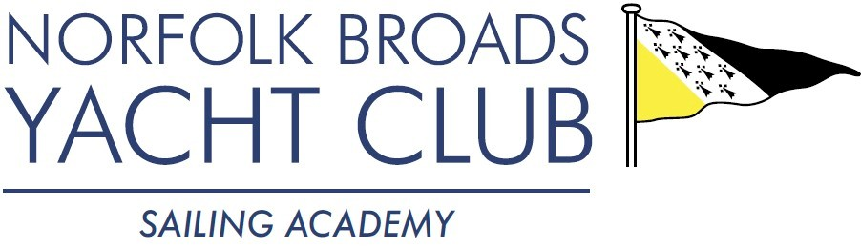
POWER BOAT LEVEL 2 COURSE 2020
JOINING INSTRUCTIONS

Dates | 1st February & 2nd February 2020
Course Information | This is a two training and assessment course delivered by Gary Ross (RYA Power Boat Instructor).  Min age: 12. Candidates under the age of 16 will be issued with an endorsed certificate  The course is designed to develop your Power Boat handling skills and in particular:  *Launching and recovery  *Securing to a buoy  *Anchoring  *Leaving a mooring and coming alongside  *What to do in the event of a ‘man over board’ situation  Upon completion of the course you will be able to have enough skills and knowledge to helm a Power Boat in the right conditions, be aware of your own limitations and those of the craft.  Please note: This course is taught in NBYC owned powerboats on Wroxham Broad. Please ensure that you are suitably dressed. Lifejackets are available if you do not have your own.
Location | Norfolk Broads Yacht Club  The Avenues Wroxham  NR12 8TS  Drive to A1151 in Wroxham, exit onto “The Avenues”. Proceed 0.7m to sharp right bend, turn left  into drive, signposted NBYC. The club is entered through a security gate at the end of the drive. You will be sent the gate code with your confirmation on receipt of payment, prior to the course.
Times | 09.30 to 16.30. Please meet Gary at the Hugh Ferrier Training Centre.
Facilities | There are warm changing rooms with hot showers, drying areas, sockets, lockers, hairdryers and toilets. There is ample parking.  During the duration of the course tea and coffee making facilities will be available in the Hugh Ferrier Training Room. The hatch in the Clubhouse might (due to possible cancellation of Saturday Junior sailing) be open on Saturday 1st February until approximately 1pm, you can purchase hot and cold snacks and drinks. Payment at the hatch can be made by cash or debit card/member smart card.  For those accompanying you there are plenty of places to hide away with a lap top or book and enjoy the views and we welcome families making the most of the space. There is WiFi - NBYC-Guest, the password is ‘Password1234’.  .
Kit List | You will need to bring with you:  - Lunch  - Personal Medication (if required)  - Passport sized photograph for the RYA Certificate  - Personal Buoyancy Aid  - It is always colder on the water, please make sure you wear plenty of layers and remember to bring a hat and gloves!  - Sensible footwear - sailing boots / wellies -Something that will keep your feet dry  - Waterproof coat and trousers  - Spare clothes, a towel, and a bin liner to take home wet clothes!
And Finally…. | We look forward to welcoming you to Norfolk Broads Yacht Club. We hope that you enjoy the course. Please don’t worry: this is a training course, with the opportunity to share the learning experience with people of similar abilities and it will be an enjoyable two days. If you have any questions during the course please don’t hesitate to ask Gary.  Should you have any queries or concerns before the course please do not hesitate to contact us.

