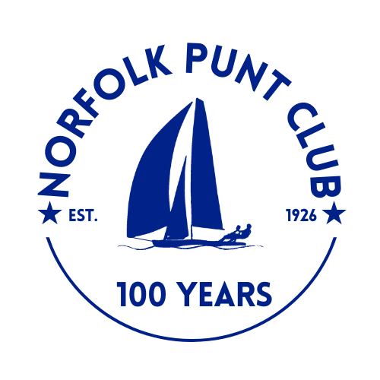



The 2026 Barton Bunny Pursuit Race

The Norfolk Punt Club hosts the race on Barton Broad on Easter Saturday, the 4th April

The Norfolk Punt Club is looking forward to welcoming club and visiting boats to Barton

for an afternoon of spring racing

Notice of Race

- Event Information
- The briefing will be at 12 noon on the NPC pontoon, Barton Broad
- The first signal will be at 12.20pm with the first start at 12.30pm
- Tow outs from the NPC moorings, Barton Turf, will be available at 11.30am
- Entries will cost £10 for single-handers and £15 for double (or more)-handers with all proceeds going to the NPC Centenary Fund
- Entries to be made via Webcollect https://webcollect.org.uk/npc until Saturday 4th April 2026 at 8am or on the day in cash on the pontoon by 11am
- Tea and cake will be served from 1pm at normal NPC prices

- Eligibility
- Open to any class of dinghy with a Portsmouth Yardstick less than or equal to that of a Bittern (1381)
- Also open to Broads One Design keelboats (e.g. YBODs, BODs, Yarmouths etc.) and River Cruisers
- Non-members welcome

- Rules
- The race will be approximately 1.5-hour pursuit race, beginning with the slowest class
- Classes will be given start times on the day and these will be published beforehand on the pontoon
- The race will be sailed in accordance with the ISAF Racing Rules of Sailing
- No boat will sail between the Dolphin mark and its nearest bank
- No boat will sail in the exclusion zone until the sound signal for the previous start
- All boats will finish at the sound signal 1.5hrs after the first start. Final positions will be as at that time. Full details to be given at the briefing
- Protests must be lodged within 15 minutes of the final boat finishing
- All visiting competitors will be deemed temporary members of the Norfolk Punt Club during the event and as such shall abide by the club’s rules

- Prize Giving
- Prize giving will commence at 2.45pm subject to the completion of any protest hearings
- Prizes will be awarded to
      - 1st, 2nd and 3rd placed boats overall
      - 1st Junior helm (aged under 18 on the day)
      - 1st Junior crew
      - 1st boats in classes with more than 4 entries
- Overall results will be published inside the Kon-Tiki hut at the end of prize giving and will also be available for viewing on the Norfolk Punt Club website

