
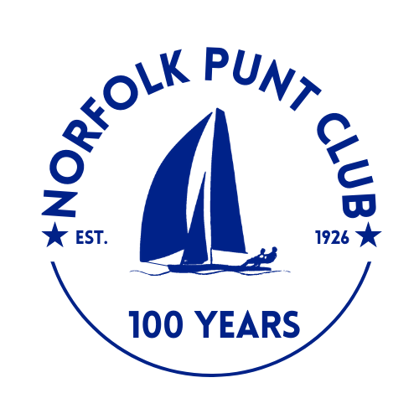


Broadland Youth Regatta

Held at Barton Broad

Hosted by the Norfolk Punt Club

Saturday the 5th September 2026

The Norfolk Punt Club is looking forward to welcoming Juniors to Barton for the NSBA Broadland Youth Regatta.
Notice of Race
- Event Information
- The Organising Authority is the Norfolk Punt Club (NPC) in conjunction with the Norfolk & Suffolk Boating Association (NSBA).
- The racing event will be the Broadland Youth Regatta (BYR) which will be held on Barton Broad on the 5th September 2026.
- The venue is the Norfolk Punt Club, based on Barton Broad, Norfolk.
- Entry & Eligibility
- Competitors must return a completed Entry Form online by 21:00 on Tuesday the 1st September. The form can be found at https://webcollect.org.uk/npc.
- There is no charge for entry, however an optional contribution of £5 per entry towards the event running costs would be welcome.
- Late entries and changes to an entry may not be accepted after this date.
- To be eligible to enter for this event you must:
  - i. Agree and Sign the online Terms and Conditions of Entry;
  - ii. Be under 19 years old on Saturday the 5th September 2026;
  - iii. Be a member of a club affiliated to the NSBA;
  - iv. Sail a dinghy (no keelboats, multihulls, or foiling boats) that is under 19 feet of overall length.
- All competitors under 18 years of age on the first day of the event are required to complete the Parent/Guardian Consent details as part of the online entry process. Each competitor under the age of 18 must have a nominated responsible adult who will remain with the competitor on the Broad. For the avoidance of doubt, multiple sailors may be assigned to one responsible adult.
- At registration, details of each competitors responsible adult will be checked and can be changed on the day.
- All visiting competitors will be deemed temporary members of the Norfolk Punt Club during the event and as such shall abide by the club’s rules

- Rules & Regulations
- The event will be governed by the current Racing Rules of Sailing (RRS) 2025 -2028 https://www.sailing.org/racingrules/
- RRS Appendix T will apply.
- RRS 35 is changed so that after the first boat finishes, the race committee may assign finishing places to boats still racing, based on their observed position on the course

- RRS 40.1 applies at all times while afloat, on pontoons, jetties and slipways. Code Flag Y will not be displayed
- In the case of conflict between the Notice of Race and the Sailing Instructions, SIs will take precedence.
- This Notice of Race may be amended by a Notice to Competitors from the Organising Authority
- Any changes to the Notice of Race or Sailing Instructions will be displayed on the ‘Official Event Notice Board’ located at the club.
- RRS 44.1 is changed so that the Two-Turns Penalty is replaced by a One-Turn Penalty.
- Competitors and support persons should note that NPC implements the RYA Racing Charter and that they will be expected to sail in compliance with it https://www.rya.org.uk/racing/rules/racing-charter
- All competitors and support boats are required to be compliant with the Broads Authority toll system.
- Communication
- The official notice board will be located electronically at www.puntclub.co.uk/broadland-youth-regatta Any communications on the event day will also be published in the Kontiki hut, on the pontoons at Barton Broad.
- For unofficial communications the Organising Authority invites everyone to join the WhatsApp Group which can be found as below:


https://chat.whatsapp.com/Lou8uPD14GQ0RiiqUKzBwT?mode=gi_t

- Sailing Instructions
- The Sailing Instructions for the event will be published no later than 3 weeks before the event and displayed on the official notice board.
- Advertising and Sponsorship
- Advertising will be permitted in accordance with the class rules of the competing fleets.
- Boats may be required to display sponsor advertising as supplied by the Organising Authority.
- Schedule
- All competitors must register on the day. Registration is open from 07:30 – 09:00.
- Registration will be in person at a marquee in the Barton Turf Adventure Centre boat park, NR12 8AZ. Registrations after this time, will not be accepted, nor will registrations at other locations (e.g. the pontoons).
- Competitors who are taking part in the Barton Regatta, the bank holiday weekend before, are welcome to leave their boats for the week.
- Competitors who arrive by road will be directed to drop their boat off at Barton Turf Adventure Centre Boat park and unload. Cars will then be asked to park in the official car park, just off Staithe Road.
- Competitors will be asked to trolley their rigged boats down to the slipways at the Punt Clubs moorings.
- Competitors may either sail out to the club pontoons on Barton Broad, or tow outs will be made available from 8.30-9.45.
- Any competitor coming by water are welcome to moor their competing boats directly on the pontoon, but must ensure they have registered.
- A briefing will take place on the club pontoons at 10.20.
- The planned racing schedule is noted below. Race start timings are approximate, and can be subject to change at the Principal Race Officer’s discretion.

- Entries will be assigned to fleets. Fleet lists will be available at registration, on the official notice board and communicated in the briefing. It is expected that fleet lists will be as follows;

- All competitors must bring food to sustain them for the day. Due to the unique nature of the Norfolk Punt Club, no cooking facilities are available.
- All competitors and support teams must bring suitable clothing for all weathers. The pontoons on the Punt Club are very exposed.
- Water will be made available to all competitors.
- Teas, Coffees, Hot Chocolate and Cakes will be available on the pontoons for a reasonable fee.
- Upon leaving the event all competitors must sign out. Before 15.30 this must be done in person on the pontoon with a nominated individual from the organising authority (whose details will be made clear at registration). Post 15.30, sign out must be done at the marquee at BTAC. Failure to sign out may result in emergency services being alerted.
- Cancellation
- The Organising Authority may cancel the event, fleets or classes and reject entries at its discretion, subject to RRS 76.
- Sailing Area
- The Sailing Area is limited to Barton Broad only.
- Competitors must not race to the west (non channel) side of the pontoons.

- Scoring
  - For all fleets, the Low Point Scoring System (RRS Appendix A4) will apply to determine individual positions.
  - When fewer than four races have been completed, a boat’s series score will be the total of her race scores.
  - When four races have been completed, a boat’s series score will be the total of her race scores excluding her worst score.
  - One race is required to constitute a series.
  - If there is a series-score tie between two or more boats, RRS Appendix A8.1 will apply.
  - If the tie still remains after applying RRS Appendix A8.1, then discarded results will be taken into account before resolving the tie by applying RRS Appendix A8.2.
  - Handicap racing shall be run using the RYA Portsmouth Yardstick Scheme. Portsmouth Yardstick Values will be taken from: https://www.rya.org.uk/racing/technical/handicap-systems/portsmouth-yardstick using both the ‘Current PY List’ and ‘Limited Data List’.

- Support Person Vessels

  - Support boats, coaches and other support persons shall stay outside channel markers where boats are racing from the time of the preparatory signal for the first class to start on that course until all boats have finished or retired or the race committee signals a postponement, general recall or abandonment.
  - No Cruisers may be moored on the pontoon from 08.00 until 17:00. Support Ribs/ Tenders may moor up on the pontoon with the organizing committee able to dictate where, if space available.
  - There may be no on the water coaching, during racing.
  - Kill cords shall be worn at all times whilst engines are running.
  - Personal floatation devices shall be worn by all persons in a support boat at all times, except briefly while adjusting clothing or in the case of cabined boats, whilst in the cabin.
- Supporters
  - We welcome supporters of sailors to the Pontoons. A regular ferry will run throughout the day to/ from the BTAC moorings to the pontoon.
- Results
- During the event, paper copies of the results may be available on the official notice board,
- Individual race or fleet results may not be available directly after each race, the timeframe of publishing results is subject to the Principal Race Officer’s discretion.
- Prizes
- If any given class, within a fleet has over 5 entrants, prizes will be presented for first, second and third for each class.
- Separate prizes will be awarded for each fleet, should there be boats who have finished first, second or third and have not been awarded a class prize.
- A number of special NSBA trophies will also be awarded, which are noted below

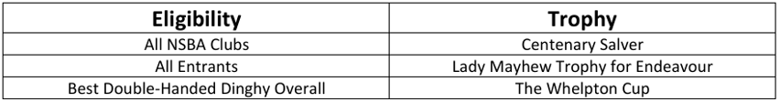

- Safety
  - RRS Rule 40 Applies – ‘each competitor shall wear a personal flotation device.’ This is applied whilst afloat, on the pontoons, jetties and slipways. Code Flag Y will not be displayed.
  - There will be no running on the Pontoon or on slipways.
  - Suitable footwear must be worn at all times.

- Insurance
  - Each participating boat shall be insured with valid third-party liability insurance with a minimum cover of three million pounds per incident or the equivalent.

- Data protection
  - The personal information you provide to the Organising Authority will be used to facilitate your participation in the event. If you have agreed to be bound by the Racing Rules of Sailing and the other rules that govern the event (the rules), the legal basis for processing that personal information is contract. If you are not bound by the rules, the legal basis for processing that personal information is legitimate interest. Your personal information will be stored and used in accordance with the Organising Authority’s privacy policy. When required by the rules, personal information may be shared with the RYA, NSBA, your national authority and/or World Sailing. The results of the event and the outcome of any hearing or appeal may be published.

- Risk Statement
- Rule 3 of the Racing Rules of Sailing states: ‘The responsibility for a boat’s decision to participate in a race or to continue racing is hers alone.’ Sailing is by its nature an unpredictable sport and therefore inherently involves an element of risk. By taking part in the event, each competitor agrees and acknowledges that:
    - They are aware of the inherent element of risk involved in the sport and accept responsibility for the exposure of themselves, their crew and their boat to such inherent risk whilst taking part in the event;
    - They are responsible for the safety of themselves, their crew, their boat and their property whether afloat or ashore;
    - They accept responsibility for any injury, damage or loss to the extent caused by their own actions or omissions;
    - Their boat is in good order, equipped to sail in the event and they are fit to participate;
    - The provision of a race management team, safety boats and other officials and volunteers by the event organiser does not relieve them of their own responsibilities;
    - The provision of safety boat cover is limited to such assistance, particularly in extreme weather conditions, as can be practically provided in the circumstances;
- It is the competitors responsibility to familiarise themselves with any risks specific to this venue or this event drawn to their attention in any rules and information produced for the venue or event and to attend any competitors briefing held for the event.

Further Information

For further information please contact the NPC Commodore, Alastair Drew at Commodore@puntclub.co.uk

