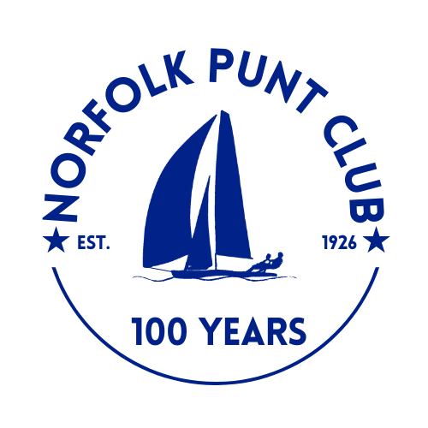
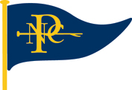

Norfolk Punt Open

Saturday and Sunday the 9th and 10th May 2026

The Norfolk Punt Club is looking forward to welcoming club and visiting Norfolk Punts

to Barton for a weekend of racing

Notice of Race

- Event Information
- Hosted by the Norfolk Punt Club on Barton Broad on Saturday 9th and Sunday 10th May 2026
- Tow outs from the NPC moorings, Barton Turf, will be available at 10.00am on Saturday and 9.30am on Sunday
- The briefing will be on Saturday at 11:00am on the NPC pontoon, Barton Broad
- The start sequence will be a 10 minute and a 5 minute with the first start at 12.00 on Saturday
- Entries will cost £20 for the weekend. To be made via Webcollect https://webcollect.org.uk/npc until Friday 8th May at 12pm or on the day in cash on the pontoon before briefing
- Tea and cake will be served from 1pm at normal NPC prices
- An evening drinks reception will be hosted at Waters Edge, Hall Road, Barton Turf, NR12 8AR

- Eligibility
- Open to all Norfolk Punt boats
- Non-members welcome
- Entrants are sailing for the Ardea Trophy

- Rules
- The race will be sailed in accordance with the RYA Rules and the Norfolk Punt Club Sailing Instructions
- Punts will be sailing on their handicap, as published by the Norfolk Punt Sailors Association.
- Protests must be lodged within 15 minutes of the final boat finishing
- 4 out of 5 races to count
- All visiting competitors will be deemed temporary members of the Norfolk Punt Club during the event and as such shall abide by the club’s rules

- Prize Giving
- Prize giving will commence around soon after the last finisher completes the last race. Prizegiving expected around 1.30 pm on Sunday subject to the completion of any protest hearings
- Overall results will be published inside the Kon-Tiki hut at the end of prize giving and will also be available for viewing on the Norfolk Punt Club website

