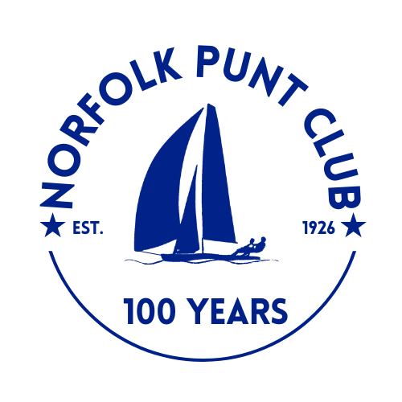


River Cruiser Open Weekend

Held at Barton Broad

Hosted by the Norfolk Punt Club

Saturday and Sunday the 6th and 7th June 2026

The Norfolk Punt Club is looking forward to welcoming members and visiting River Cruisers to Barton for a weekend of racing. Results to count towards the Sabrina and Snowbird RCC trophies.
Notice of Race

- Event Information
- Hosted by the Norfolk Punt Club on Barton Broad on Saturday 6th and Sunday 7th June 2025
- Four races; 2pm and 4pm on Saturday, 10am and 12pm Sunday
- The briefing will be on Saturday at 1.00pm on the NPC pontoon, Barton Broad
- The start sequence will be a 10 minute and a 5 minute with the first start at 2pm on Saturday
- Entries will cost £20 for the weekend. To be made via Webcollect https://webcollect.org.uk/npc until 6pm on Friday 5th June or on the day in cash on the pontoon by 12.30pm
- Tea and cake will be served from 1pm at normal NPC prices
- Subject to the weather we hope to be able to offer a ‘bring your own’ barbecue from 6.30pm on the Saturday evening

- Eligibility
- Open to River Cruisers
- Non-members welcome
- Entrants are sailing for the following trophies:
- The White Horse Trophy for the overall winner of the weekend
- The Barton Broad Cruiser Challenge Trophy for winner of the A fleet
- The Moonshadow Knob for the winner of the B fleet
- The Achievement Trophy for the highest placed yacht on a handicap of 0 or higher

- Rules
- Races will take place in accordance with RYA rules and the Norfolk Punt Club Sailing Instructions. The NPC has been asked by the RCC Committee to make clear that ‘For the purposes of the definition of ‘Start’ and ‘Finish’ and rules 21.1, 29.1, 30 and 44.2 of the RRS (but not any other rules) the term "hull" includes a boat's bowsprit in its normal position’

- Protests must be lodged within 15 minutes of the final boat finishing
- All 4 races to count
- All visiting competitors will be deemed temporary members of the Norfolk Punt Club during the event and as such shall abide by the club’s rules

- Prize Giving
- Prize giving will commence around 1.30pm on Sunday subject to the completion of any protest hearings
- Overall results will be published inside the Kon-Tiki hut at the end of prize giving and will also be available for viewing on the Norfolk Punt Club website

