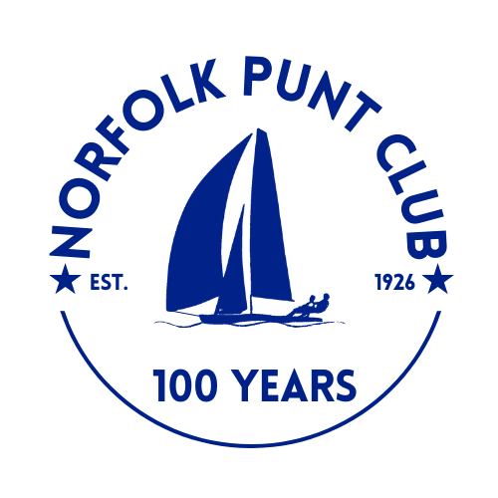
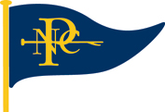

Keel Boat Open Weekend

Held at Barton Broad

Hosted by the Norfolk Punt Club

Saturday and Sunday the 13th and 14th June 2026

The Norfolk Punt Club is looking forward to welcoming club and visiting YBODs and other keel boats

to Barton for a weekend of racing

Notice of Race

- Event Information
- Hosted by the Norfolk Punt Club on Barton Broad on Saturday 13th and Sunday 14th June 2026
- Tow outs from the NPC moorings, Barton Turf, will be available at 10.30am on Saturday and 9.30am on Sunday
- The briefing will be on Saturday at 11.00am on the NPC pontoon, Barton Broad
- The start sequence will be a 10 minute and a 5 minute signal, with the first start at 12.00pm on Saturday
- Races at 12pm, 2pm and 4pm on the Saturday, 10.30am and 12.00pm on Sunday.
- Entries will cost £20 for the weekend. To be made via Webcollect https://webcollect.org.uk/npc until Friday 13th June at 6pm or on the day in cash on the pontoon by 1pm
- Tea and cake will be served from 1pm at normal NPC prices
- Subject to the weather we hope to be able to offer a ‘bring your own’ barbecue from 6.30pm on the Saturday evening

- Eligibility
- Open to all Yare and Bure One Design and other keel boats
- Non-members welcome
- Entrants are sailing for the following cups:
- Consortium Cup
- Whelpton Trophy for the highest place NPC member
- NPC Mixed Keels Open Trophy
- Helios Trophy

- Rules
- The race will be sailed in accordance with the RYA Rules and the Norfolk Punt Club Sailing Instructions
- There will be separate starts for YBODs and mixed keel boats
- No keel boat will enter the exclusion zone until the YBOD start has been sounded
- Protests must be lodged within 15 minutes of the final boat finishing
- 4 out of 5 races to count
- All visiting competitors will be deemed temporary members of the Norfolk Punt Club during the event and as such shall abide by the club’s rules

- Prize Giving
- Prize giving will commence around 1.30pm on Sunday, subject to the completion of any protest hearings
- Overall results will be published inside the Kon-Tiki hut at the end of prize giving and will also be available for viewing on the Norfolk Punt Club website

