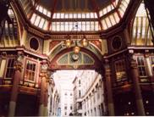
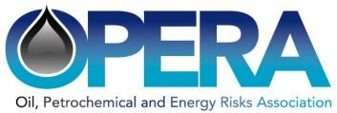
Insuring Ageing Facilities, for Better or Worse – October 30th 2012
Registration
Total fee per reserved place £125.00.
Please log on to:-
http://webcollect.org.uk/opera

Seminar Sponsors

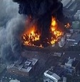
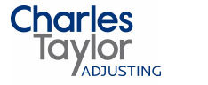

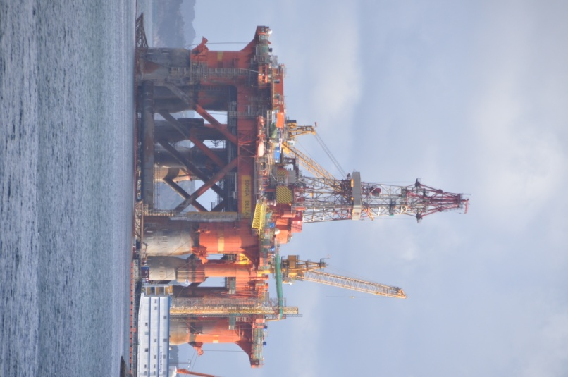




The Swiss Re Lecture Theatre is a modern facility with full audio/visual installation. All refreshments will be inspired by the resident chefs, to ensure that you can concentrate and absorb the comprehensive programme.
INSURING AGEING FACILITIES, FOR BETTER OR WORSE
OIL PETROCHEMICAL AND ENERGY RISKS ASSOCIATION - OPERA

BY KIND PERMISSION OF SWISS RE

Tuesday October 30th 2012

Registration 09.00

Conference Starts 09.30
Finish 17:00

The Lecture Theatre
10th Floor, The Gherkin
(formerly Swiss Re Building)
30 St Mary Axe, London, EC3A 8EP

Insuring ageing facilities, for better or worse
The Energy and Petrochemical Industry is in the middle of a sea change. In the developed world, assets are ageing and coming under commercial pressure from new installations in the Middle and Far East.
Offshore, many facilities have surpassed the end of their original field life and yet are being considered for sub sea tie backs and gathering. How do we assure ourselves that they are still fit for purpose?
Operators have to find the right balance for safe and profitable operation and this seminar brings together the experts, research and experience in the field of asset integrity in one place at one time.
The seminar is aimed at risk engineers, surveyors, loss adjusters, brokers, underwriters, risk managers, lawyers and all who are involved in the insurance market for energy risks.
Seminar Topics:
- Contribution of age factors to loss profile
- Regional aspects of ageing
- Life extension
- Implications for claims
Seminar Speakers:
The panel of speakers will include:
Morning
Judith Hackitt CBE - UK HSE, Keynote Address
Dave Mansfield - ESR Technology, Ageing Plant in the Process and Chemical Industries
Andy Goddard – Validus, An Insurance Engineer’s Perspective on Ageing Assets
Tim Bibbs - Mensor, Russian Risks, A View from London
Tony Hall – Welaptega, Mooring Integrity for Offshore Oil & Gas
Szen Ong – bpptech, Aging Subsea Assets – Riser and Umbilical Case Studies
Afternoon
Matthew Free - Arup, Lessons from Post-Earthquake Field Investigations – Implications for Design of Facilities
Brian Hudson ABB, Ageing of Equipment and its implications for inspection
Steve Mabey - Jacobs, Optimising Turnarounds to Achieve Asset Integrity
Gaetan Prodhomme – Ineris, Benchmarks for Ageing Industrial Installations
OPERA reserves the right to make changes to the contents of the published programme as necessary, without notice. The programme is correct at time of printing.
Seminar Fees:
The seminar fee is £125. The fee includes a buffet lunch and refreshments.
The fee is payable online in advance and is non-refundable for cancellations received after October 15th 2012; before that date, an administrative charge of £30.00 will be made.
For queries regarding registration contact Ian Wells-Gaston at: ianw_g@me.com
All bookings must be made via the online Webcollect facility which can be accessed at www.oilpera.com or at http://webcollect.org.uk/opera
For security reasons booking and payment must be made in advance. There will be no admission on the day without prior booking. Early booking is advised, since a full attendance is anticipated.
The seminar papers will subsequently be made available on the OPERA website at:
www.oilpera.com

