Rollesby Broad Sailing Club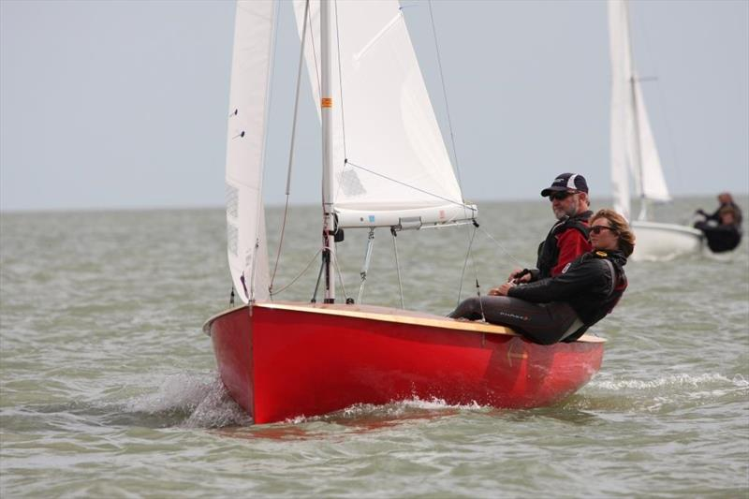

A conversation with Mike McNamara
Friday the 26th of April – 7.00pm in the club house
Tea and coffee available, bring your own alcohol, nibbles etc.

Entrance by ticket (£5.00 per head for the Museum of the Broads)use RBSC Webcollect

Any questions chrispfos@outlook.com

