1. RULES
  - The racing will be governed by the rules as defined in the Racing Rules of Sailing (RRS) 2025 - 2028, the prescriptions of the RYA, the appropriate Class Rules and these Sailing Instructions. Where conflict occurs, these Sailing Instructions shall take precedence.
  - Each competing boat must hold 3rd party insurance to the value of £3,000,000. Club boats that are borrowed are covered by the club’s insurance.
  - To ensure that the Club has appropriate details that may be needed in an emergency situation, all competitors must have entered for both the Season’s racing and the day’s event using the appropriate Webcollect entry forms. Under 18’s on the day of the event must have had a paper copy of their Parental/Guardian Consent form for the Season lodged with the Club.
  - If while racing, any collision occurs with a moored vessel, the boat concerned must retire immediately and report the incident to the RO who must record the names of both the competitor, the moored vessel and area of any damage. This may be required for any subsequent enquiry or insurance claim. If the contact is with hands only fending off, and
there is no contact by hull or spars, this is not considered to be a collision. If the collision occurs before the start, or after the finish of a race, the competitor should still notify the Race Officer

- CHANGES TO THESE SAILILING INSTRUCTIONS
Changes to these Sailing Instructions (e.g. Start Line at the Jetty rather than Start Hut, or for a Pursuit Race) will be given verbally by the Race Officer at the Briefing one hour prior to the published start time of the day’s event. Competitors should make every effort to attend the Briefing as failure to do so will not be accepted as a reason for not being aware of changes to the Sailing Instructions for the event.

- SIGNALS MADE ASHORE (At the Pierhead)
  - Signals made ashore will be displayed on the flagstaff at the end of the SYC Pier.
  - Flag AP with 2 sound signals when hoisted indicates that the first race of the day is postponed. When it is lowered with 1 sound signal, the Warning Signal for the first race of the day will be made in not less than 45 minutes.

4. SCHEDULE OF RACES
It is hoped that the Racing Programme described in the 2026 Handbook will be adhered to. These Sailing Instructions therefore cover the 4 Early and Late Season (main) series, the River Race and Pursuit Race series and the Hestan and Palnackie Pursuit Races. The second race on a day will start as soon as is practicable after the completion of the first race. It is hoped that on some days, additional more informal races may be held alongside the scheduled event for less experienced Cadet members, and if this is the case, details will be given at the Briefing.

5. CLASSES AND CLASS FLAGS
5.1 Everyone will be in the same fleet. The Class flag will be Flag D (Yellow/Blue/Yellow horizontally).
5.2 If a Cadet fleet is racing, they will use Flag T (Red/White/Blue vertically)
5.3 Boards representing flags may be used in the starting sequence instead of actual flags.

6. RACING AREA
The racing area is shown in Appendix A except for the following exceptions:
1) River Races when courses will start from the Club Jetty and proceed upstream or downstream in the River and may go into the Estuary as far as Marks U, V, and K.
2) The Hestan Pursuit Race will round Hestan Island. Details will be given at the Briefing.
3) The Palnackie Pursuit Race which will start at the Club Jetty and proceed upstream to Palnackie. Details will be given at the Briefing.

7. THE COURSE
7.1 Courses will be set within the race areas defined above and displayed at the Start Hut when starting from there, with
a red background indicating that a mark is to be rounded to port and green to starboard. Courses starting from the
Committee Boat, if Alicat, will be similarly displayed as at the Start Hut. Courses starting from the Jetty or a RIB will
have their courses described verbally by the Race Officer at the Briefing,
7.2 If sailing laps, Boats must pass through the Start Line, from the direction of the last mark, at the commencement of
each round of the course.

7.3 If sailing laps, a race will at most consist of four laps of the set course. A race may be shortened in one of two ways:
1) The Start Hut, Committee Boat or Club Jetty will display flag S and make two sound signals as the leading
boat rounds the last mark.
2) Flag S may be displayed from a support boat positioned adjacent to a mark of the course. The race will
finish between that mark and Flag S on the support boat, which will be positioned so that crossing this
finishing line allows the mark to be rounded on the required hand. Two sound signals will be given as the leading boat approaches.

8. MARKS
Marks will consist of SYC fixed and movable orange or yellow mark buoys or other features (e.g. mooring buoys)
described at the Briefing.

9. AREAS THAT ARE OBSTRUCTIONS
The locations of these obstructions are shown in Appendix A except for the moored boats.
9.1 Rough Island: Rough Island must not be passed on its eastern side. Note there are un-marked submerged rocks close
to the shore on the western side.
9.2 Rough Island / Spring Stones Rocks: Boats must, at all times, pass to the south of Spring Stones Rocks at the southern
end of Rough Island. These rocks are submerged for some time before and after high water. The Reef may be marked
by a small temporary buoy, but this will not always be the case.
9.3 Nets: There are 3 stakes in line posing a potential hazard at the northern end of the Horse Isles Bay peninsula that are
covered at high water. The outermost one is 12-15m from the shore. Boats are advised to keep clear.
9.4 Moored boats: When racing in the river, competitors are asked to keep well clear of the moored boat allowing for the
swing due to tide and wind.
9.5 Vessels (power or sail) constrained by their draft or towing other vessels: Particularly in the River, and to varying
extents in the Firth, vessels with restricted manoeuvrability may not be able to keep clear, so should be kept well
clear of.

10 THE START
10.1 Races will be normally be started by using RRS Rule 26 with the warning signal given 5 minutes before the start signal. At the Race Officer’s discretion, this may be changed to the 3/2/1/go sequence and if so, that will be mentioned at the Briefing.
10.2 The Start Line at the Start Hut will be either:
1) A transit from the flagpole in front of the Start Hut and the inner distance mark, which is a perch located
in the river in front of the Start Hut. An outer distance mark may be laid but this does not form part of
the Start Line except that boats must start between the inner and outer distance marks.
2) When a blue board with a white diagonal stripe is displayed, the start line will be between the mast and
the outer distance mark. Although not necessarily close to the line the perch in front of the Start Hut will
act as an inner distance mark.
10.3 The Start Line for the River and Pursuit Races, and for a Committee Boat start (i.e. from Alicat or a RIB) will be defined by the Race Officer at the Briefing
10.4 Individual and general recalls will be made in accordance with RRS Rule 29.
10.5 A boat starting later than 15 minutes after her starting signal will be scored Did Not Start without a hearing. This
changes RRS rule A4.
10.6 Minimum Wind Strength. Races will not be started unless the Race Officer is satisfied that the wind strength in the
starting area, and to the best of his/her belief on the rest of the course, is suitable for sailing the course given the
estuary’s tidal conditions.
10.7 Races may be cancelled or abandoned at the Race Officer’s discretion whenever wind and sea state are considered
marginal for the assembled racing fleet. (Note to Race Officers: The Club requires that the Club Sailing Risk
Assessment be completed even when conditions appear to be benign as they can change unexpectedly. This will aid making or not making a cancellation decision when conditions are marginal.)

11. THE FINISH
Other than as provided in 7.3(2) above and for Pursuit Races, the Finish Line will be the same as the Start Line and boats must finish from the direction of the course from the last mark. In Pursuit Races, the decision of the Race
Officer on relative positions will be final and the only grounds for protest will be for mis-identification.

12. PENALTY SYSTEM
The one and two turn penalties as described in RRS rule 44.1 & RRS rule 44.2 shall apply. RRS rule 44.3 shall not apply.

13. TIME LIMITS
13.1 If 2 races are scheduled for the day, the normal time limit for the first boat finishing will be 75 minutes, though this
may be extended at the discretion of the Race Officer. Subsequent boats must finish within 30 minutes of the first
boat, except that at the discretion of the Race Officer, boats that he/she expects to finish outside of this limit may be
given their observed position on the course and instructed by rescue boats to return to the starting area for the start
of the next race or the finish of sailing for the day. If competitors are finished in this way, they must return
immediately to the starting area. There will be no redress if they delay and miss their next start.
13.2 If one long is scheduled for the day, the normal time limit for the first boat finishing will be 135 minutes, though this time may be extended at the discretion of the Race Officer. Subsequent boats must finish within 40 minutes of the first boat, except that at the discretion of the Race Officer, boats that he/she expects to finish outside of this limit may be given their observed position on the course and instructed by rescue boats to return to the starting area for the finish of sailing for the day. If competitors are finished in this way, they must return immediately to the starting area and head back to the pier.

14. PROTESTS AND REQUESTS FOR REDRESS
Competitors are reminded that Sailing is a friendly sport. If they have a minor collision or incident and they don’t know
which of the boats involved is in the wrong, it is suggested that both do turns so that whichever of them was wrong is
exonerated. Resort to the protest procedure outlined below should only be used as a very last resort in the event of
serious damage to one or both competitors and neither of them think they were in the wrong. When a protest is
lodged, a boat may at the same time request RYA Arbitration as described in RRS Appendix T, or the Protest
Committee or Race Committee may offer it. Note that the clauses 14.1 – 14.6 below replace RRS Part 5 sections A
and B except when a formal protest is requested as stated in 14.4 and 14.5 below.
14.1 If a boat wishes to protest against another competitor, they must inform them and the Race Officer at the first
opportunity (before returning ashore if racing from then Start Hut other than in Pursuit Races). If a boat wishes to
protest against the Race Office, they must also inform the Race Officer as above. In both cases, failure to do this will
result in the protest being rejected. RRS Rule 60.2(a)(1) will not apply for races covered by these SIs.
14.2 The protest time limit for protests between boats will be 15 minutes of the last involved boat returning to the Jetty.
Protestor and Protestee, together with their witnesses, if any, must remain in the vicinity of the Pierhead until the
protest is heard.
14.3 Unless the protest is for redress against the Race Committee, the Race Officer will chair an informal meeting with the
competitors involved. He may be supported by the Assistant Race Officer and a third person with knowledge of the
Racing Rules. If the protest is against the Race Committee, an independent person with knowledge of the Racing Rules
will be asked to chair the meeting. The latter may also choose up to 2 further independent persons in support.
14.4 For protests between competitors, the protestor will be asked to verbally describe the incident. The protestee will be
asked to say whether he agrees with the description, and if not, where he/she disagrees. in the event of
disagreement, they will be asked to name one witness each that they are aware of. They will then retire while the
committee considers the case. The committee will decide whether to call the witnesses, if any, and after hearing their
descriptions, will decide whether one or both boats committed an offence that would normally warrant
disqualification. If so, the offending boat(s) will be told of the committee’s view and given the chance to accept a time
penalty decided by the committee or to retire from the race. If the protestor or protestee do not accept the
committee’s decision, they have the right to request a formal protest hearing and will be given 1 hour to submit a
formal protest form after which RRS Part 5 sections A and B will apply.
14.5 For protests against the Race Committee, the same procedure as in 14.4 with the Race Officer being the protestee will
be followed. If the protest is found to be valid, the Protest Committee will decide on the appropriate redress. As in
14.4 above, in the event of non-acceptance of the committee’s findings, the protestor or protestee can submit a
formal protest form within 1 hour after which RRS Part 5 sections A and B will apply.
14.6 If a protest committee awards average points for a series, it shall be for the whole series, not races sailed prior to the one involving the protest.

15. SCORING SYSTEM
15.1 The scoring system will be the Low Points scoring system of RRS Appendix A as follows: 1st place = 1 points,
2nd place = 2 points, 3rd place = 3 points, etc. RRS A5.3 will apply, not A5.2. Two races are required to be completed to
constitute a series. Up to 3 races sailed, no discards; 4 - 5 races sailed, 1 discard; 6 - 7 races sailed 2 discards; 8 - 9
races sailed 3 discards.
15.2 Series tie. If two or more boats have the same points total, the tie will be broken in accordance with RRS Appendix A8.

16. SAFETY REGULATIONS
16.1 Adequate personal buoyancy for crew members shall be worn at all times whilst racing. Neither a wetsuit nor a drysuit
constitute adequate personal buoyancy. This changes RRS rule 40.1; flag Y will not be displayed.
16.2 A boat that retires from a race shall notify the Race Officer or an official boat as soon as possible.
16.3 All boats shall carry a painter at least 5 metres long suitable for towing behind a rescue boat.

17. REPLACEMENT OF CREW OR EQUIPMENT
17.1 A helm enters a series with a specified boat. If he/she changes boat, it will be considered as a separate entry unless prior consent for the change has been obtained from the Sailing Committee which will usually be given if the change is like for like. (Note that ILCAs and Toppers entered with full or intermediate rigs may change to a smaller or larger rig without obtaining consent, but will race under the lowest Portsmouth Yardstick of the rigs used in the series. This may well require recalculation of earlier series race results.) Different crews may be used and the crew may swap with the helm if this is required during a race as long the nominated helm steers for the majority of the time.
17.2 Distinguishing Numbers. Under exceptional circumstances, the Race Officer may permit a boat to use sails carrying a distinguishing number other than that required by RRS 77 and RRS Appendix G. Such permission is only valid if given by the Race Officer prior to the start of the race.
17.3 Where a hull, spars or sails are damaged to such an extent that they cannot be used in the next race after all reasonable steps are taken to carry out repairs then competitors may change equipment with the prior agreement of the Race Officer.

18. EQUIPMENT AND CLASS CONFORMITY
To the best of the helm/owner’s knowledge, every boat shall comply with the current relevant class rules. Failure to do so in a way that creates an advantage may result in disqualification without a protest hearing. This changes RRS
78.1 and 63.2.

19. RISK STATEMENT
Rule 3 of the Racing Rules of Sailing states: “The responsibility for a boat’s decision to participate in a race or to continue racing is hers alone.”
The Solway Yacht Club will not accept any liability for material damage or personal injury or death sustained in
conjunction with or prior to, during, or after an event they have organised.
Sailing is by its nature an unpredictable sport and therefore inherently involves an element of risk. By taking part in an event, each competitor agrees and acknowledges that:
- They are aware of the inherent element of risk involved in the sport and accept responsibility for
the exposure of themselves, their crew and their boat to such inherent risk whilst taking part in the event.
- They are responsible for the safety of themselves, their crew, their boat and their other property
whether afloat or ashore.
- They accept responsibility for any injury, damage or loss to the extent caused by their own actions or omissions.
d) Their boat is in good order, equipped to sail in the event and they are fit to participate.
e) The provision of a race management team, support boats and other officials and volunteers by
the event organiser does not relieve them of their own responsibilities.
- The provision of support boat cover is limited to such assistance, particularly in extreme weather conditions, as can be practically provided in the circumstances.
- It is their responsibility to familiarise themselves with any risks specific to this venue or this event drawn to their attention in these SIs or at the Briefing, which they should attend.

Appendix A

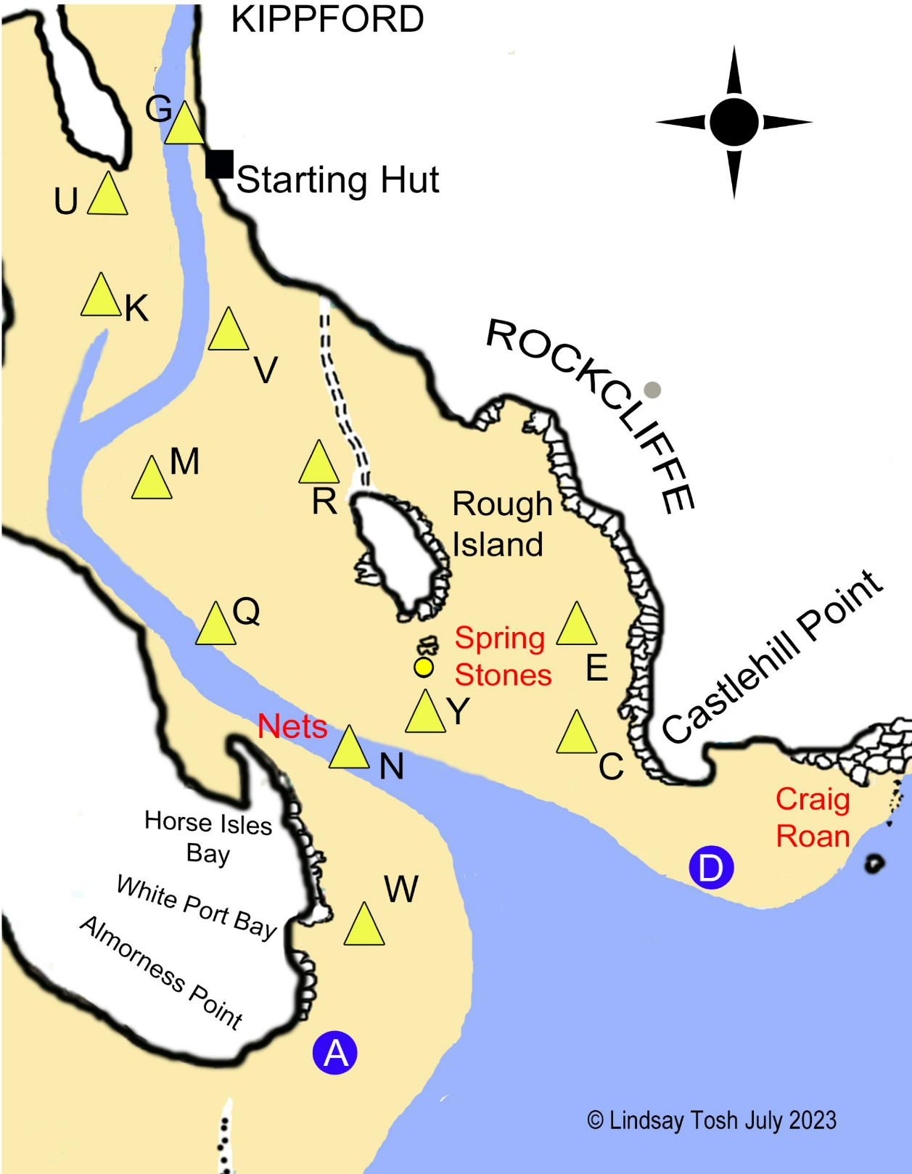

Notes:
The main channel now runs SW from G, past K, instead of taking the curved route shown above.
Not all marks (e.g. A and D) may be laid and positions are approximate only (e.g. V and N will probably be further west than shown and Y further east).

When Niclola’s revised chart becomes available, it will be used instead.

