SOLWAY YACHT CLUB
RNLI REGATTA AND
KIPPFORD WEEK
3rd – 8th August 2024

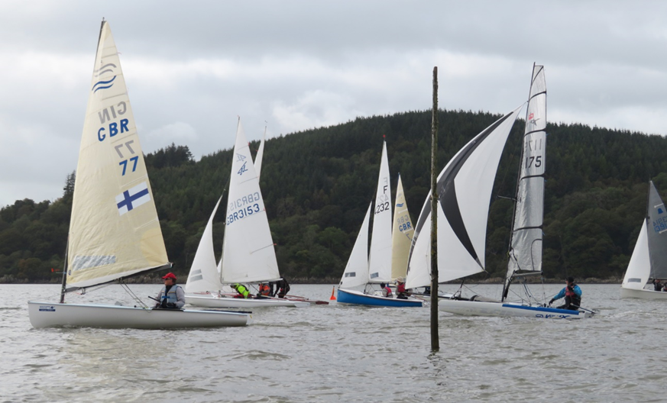
RNLI REGATTA AND OPEN WEEK AND FOR
DINGHIES - MULTIHULLS - OPEN KEELBOATS
(PN 600 TO 1450 INCLUSIVE) - CRUISERS
(MONO AND MULTIHULL)

Solway Yacht Club, The Clubhouse, Kippford, Dalbeattie, Dumfries and Galloway
DG5 4LL
Tel: 01556 620312
www.thesyc.com
WELCOME
Solway Yacht Club invites you to join us for our annual RNLI Regatta and Kippford Week, offering great sailing in a setting of outstanding natural beauty. Kippford Week is a family friendly series providing competitive racing and after racing social events. It attracts regular competitors from all over Scotland, England and frequently beyond.

The sailing area (see chart below) is a scenic estuary leading into the Solway Firth. Racing for the smaller boats usually takes place in the more sheltered area stretching from where the river begins to open out to the fringes of the Solway Firth. The estuary gives competitors the exciting experience of sea sailing but in an area normally sheltered from the strongest winds and rougher seas. Tides and currents add to the mix. Flying Fifteens and Cruisers normally start inside the estuary and venture out into the Firth itself where Hestan Island is often treated as a mark of the course, so bringing other factors into play.

If weather conditions and safety boat provision permit, it is hoped to vary the format of racing for the dinghies with some days having one longer race and others 2 shorter ones. If safety cover is available Handicap 1 may sail some or all races on the outer courses with the Flying Fifteens. Similarly, depending on conditions, the RNLI Regatta may be one longer race.

The large and comfortable clubhouse is in an elevated position with views over to Glen Isle and beyond. It is the venue for most of the club-organised social life of the week. There are also many private parties as well as get-togethers in The Anchor or The Mariner pubs.

The Club site has a large boat park and offers excellent launching, pontoons and guest moorings. The estuary dries out but flat areas have been created adjacent to the pontoons.

ACCOMMODATION & PARKING
There are many hotels and boarding houses within easy walking or motoring distance as well as caravan, camping and holiday chalets nearby, but early reservations are advised.

There is limited car parking space at the club site and the public car park. However, please respect local businesses’ interests. For the safety of competitors and spectators, vehicles may not be driven onto the pier area and boat park other than to drop off or collect boats.

CATERING & BAR
Hot and cold catering will be available on all race days before or after racing depending on the race times. The Club is fully licensed and competitors and listed accompanying visitors will be made Temporary Members for the duration of their stay.

HOW TO FIND US

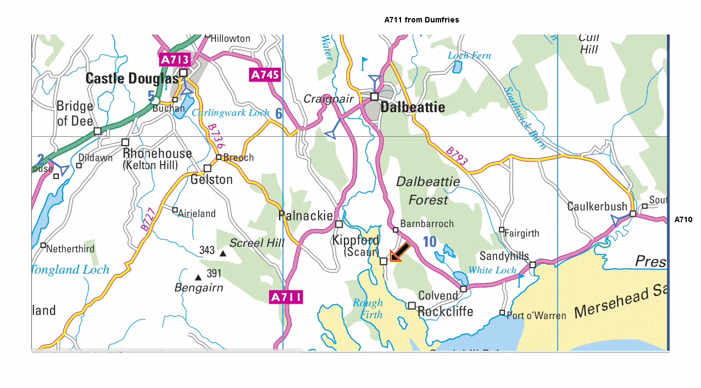
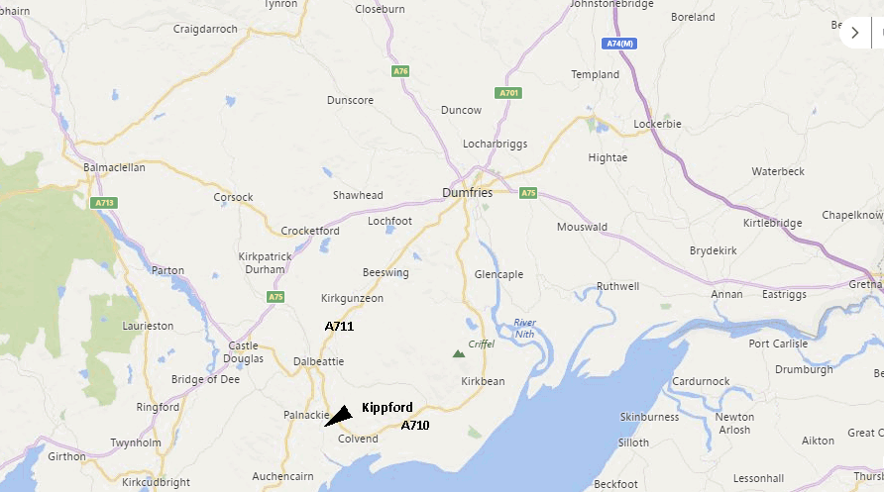

Kippford lies to the south of Dalbeattie along the A710. From the west, follow the A745 and then the A711
from Castle Douglas to the boundary of Dalbeattie. From the north, follow the A711 from Dumfries until the
far end of Dalbeattie. For both, now take the A710, which is signposted “Solway Coast”. Follow this road for
around 3 miles and then turn right at a sign for Kippford. The clubhouse is just before the foot of the hill on
the left and the boat park is on the right just round a sharp left corner.

CONDITIONS

- The meeting will be open to all dinghies, catamarans and keelboats with PN 600 – 1400. It is planned that Cruisers will use the new RYA YTC scheme, so Cruiser owners should apply to the RYA to get their ratings (N.B. There is no charge for doing this, but they should do so in good time.)

- The racing will be governed by the Racing Rules of Sailing (RRS) 2021- 2024, the event Sailing Instructions and the relevant Class Association rules.

- The entrant will be deemed to be the helmsman named on the entry form.

- Changes of hull or sail from those described on the entry form will not normally be allowed, but in event of damage or other circumstances must be notified to and approved by the Principal Race Officer and / or Sailing Secretary prior to commencement of the race or races in which they are being used.

- During the series the crew may be swapped, but the Race Officer must be notified prior to commencement of the race or races affected. Helms as indicated on the entry must always be part of the boat’s crew.

- Personal buoyancy must be worn by all competitors. Boat buoyancy may be subject to scrutiny. Relevant boats should carry an appropriate anchor with at least 10 metres of suitable warp. A suitable painter of at least 5 metres must be carried on all boats other than cruisers.

- Dinghy handicap fleets will normally be split into fast, medium and slow fleets using RYA PY numbers and depending on the number of entries.

- At the discretion of the Race Committee (Commodore, Sailing Secretary and Race Officers) class fleet status may be granted to any class having enough entrants by midnight Wednesday 31st July, though this may not mean they will be granted a separate start.

- A tally system will be used to ensure all competitors return safely after racing. With the exception of the cruiser fleet, all competitors are obliged to use the system and to cooperate fully with its requirements.
- Visitors and competitors are asked to respect the local amenities and residents during their stay at Kippford.

- Children under 14 are not permitted in the clubhouse after 22:00.

- Dogs should be kept on a leash at all times.

- The Medical and Consent form must be completed online. In addition, where the competitor (helm or crew) is under 18, a paper copy (see below after Course Card) must also be completed, signed by the parent or guardian and delivered to the Sailing Secretary before or at the Briefings to be held at 09.25hrs on Saturday 3rd August for the RNLI Regatta and at 19.00hrs the same day for Kippford Week in the Clubhouse.

- Any alterations to these conditions or other details of this entry form shall be at the sole discretion of the Race Committee of Solway Yacht Club.

SOCIAL PROGRAMME
Full details of the social programme will be issued nearer the time. Watch out for this on the Club Website and the
opportunity to book tickets for certain events.

RACING PROGRAMME 2024

Day | Date | Format | Time or  1st Warning Signal | HW | Tide  Height  m
Saturday | 03 August | RNLI Regatta Briefing  RNLI Regatta  Kippford Week Briefing | 0925  1025  19.30 | 1155 | 7.3
Sunday | 04 August | Kippford Week | 11.10 | 12.40 | 7.5
Monday | 05 August | Kippford Week | 11.45 | 13.15 | 7.6
Tuesday | 06 August | Kippford Week | 12.20 | 13.50 | 7.6
Wednesday | 07 August | Kippford Week | 12.50 | 14.20 | 7.6
Thursday | 08 August | Kippford Week | 13.20 | 14.50 | 7.5

Dinghy, Cruiser and F15 Fleets – Starts
Starting sequences will be described in the Sailing Instructions

Warning times shown are the times of the warning signal for the first start. Sailors should be aware that it can take some time to reach the racing area. Please ensure you launch or weigh anchor in sufficient time. Subsequent races in a day will start as soon as practicable after the end of the previous race.

ENTRY FEES
Entry Deadline
For both the RNLI Regatta and Kippford Week: 24.00 on Thursday 1st August 2024.
Late entries for both Kippford Week and the RNLI Regatta will be considered at the discretion of the Race Committee on payment of an additional £10 to the fees listed below which will be donated to the RNLI.

RNLI Regatta (all entry fees go to RNLI Kippford)
Crewed £20 Club Members £20 Helms who competed in Cadet Week 2024 £10
Single-handed £20 Club Members £20 Helms who competed in Cadet Week 2024 £10

Kippford Week – or part of week

Crewed £100 Club Members £85 Helms who competed in Cadet Week 2024 £40

Single-handed £85 Club Members £70 Helms who competed in Cadet Week 2024 £35

Online entries are required at https://webcollect.org.uk/syc which is also accessible on the Club Website. However, paper copies of the consent form for under 18s are required – see Condition 13 above which may be posted or handed in at the Briefing.

Anyone having difficulty using Webcollect may post a paper copy of the entry form (see below after Course Card) to John Broadbent, Bendouran, Colvend, Dalbeaatiie. DG5 4QD, with a cheque entry fee, posted 1st Class by Tuesday 23rd July so the latter can complete the Webcollect entry on their behalf by the entry deadline date.

Please make cheques payable to “Solway Yacht Club”.

Any queries, please phone John Broadbent, SYC Sailing Secretary, on 01556 630424.

SAILING AREA

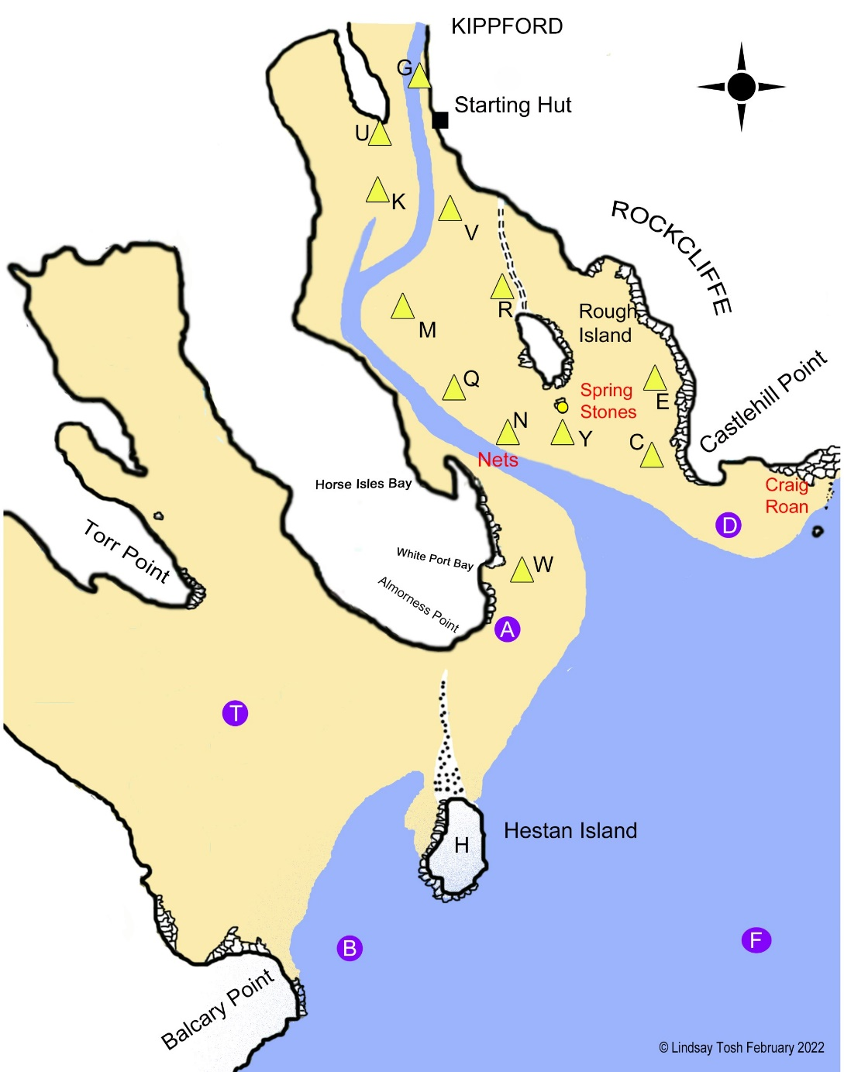

PAPER ENTRY FORM FOR THOSE HAVING DIFFICULTY WITH WEBCOLLECT

Please use BLOCK CAPS for clarity

Helm’s First Name __________________ Helm’s Surname ___________________________ If under 18, D of B ___/___/_____

Crew’s Name(s) (with D of B if under 18)_______________________________________________________________________

Helm’s Club or RYA Membership no.________________________________________________

Helm’s Address ____________________________________________________________________________________________

_____________________________________________________________________________ Postcode__________________

Tel__________________________________ Email ____________________________________________________________

Boat Class _____________________________ Sail No______________
(Please be precise e.g. Laser Radial, RS Feva XL)

Boat Insurance Company and Policy No. ____________________________________________________

Please list the name(s) of your party if additional people will wish to use the club’s facilities, with ages if under 18.

Name______________________________ Name____________________________

Name______________________________ Name____________________________

If necessary, would you be prepared to serve on a protest committee? Yes/No

I agree that Solway Yacht Club accept no liability for damage or injury to, or caused by my boat, her equipment or crew, or other personal belongings ashore, however arising. I accept full responsibility for myself, my crew and my boat and possessions whether afloat or ashore and I confirm that my boat is covered by third party insurance for a minimum amount of £3,000,000. I declare that I am an amateur member of a Yacht or Sailing Club recognised by the RYA or a personal member of the RYA . I certify that the boat has a valid Class Certificate and that the sails to be used have been officially certified, where necessary, in accordance with the class rules. I agree to be bound by the Racing Rules of Sailing and by all other rules that govern this event

Event prices – See above £_______._____

Kippford Week and Regatta 

Kippford Week only 

Regatta only 

Signed ____________________________________________________

Date _______/______________/2022

RNLI Regatta (all entry fees go to RNLI Kippford)
Crewed £20 Club Members £20 Helms who competed in Cadet Week 2024 £10
Single-handed £20 Club Members £20 Helms who competed in Cadet Week 2024 £10

Kippford Week – or part of week

Crewed £105 Club Members £90 Helms who competed in Cadet Week 2024 £45

Single-handed £80 Club Members £65 Helms who competed in Cadet Week 2024 £30

Late entries – An additional £10 which will be donated to the RNLI

SOLWAY YACHT CLUB

MEDICAL AND CONSENT FORM

Data Protection

Under the General Data Protection Regulations, Solway Yacht Club will collect and retain the data on this entry form as follows:

- The data will be collected in accordance with the club’s Data Privacy Policy (copy on request)
- The bases of processing these data will be either Contract or Legitimate Interest as per the policy with the exception of photography and medical data, for which consent is sought below.
- The data will be collected and securely retained by the Sailing Secretary
- The data will be used to facilitate the event that you are applying to enter.
- The data may be disseminated as required to any or all of: race officials, results coordinators, instructors and coaches, Cadet Officer, Piermaster/beachmaster, safety crews and those providing catering. Results may be publicised in the media, on the club website and in club publications such as the handbook.
- The data will be retained only for as long as is required to facilitate the event except that name and contact details may be retained for one year approximately to publicise the following year’s event. Qualifications obtained at a training event will be retained to enable further training.
Medical

Do you or your child under 18 have any allergies, ailments, illnesses or conditions that need to be taken into consideration if injured or taken ill while on the water or in club premises. If none exist please leave blank. It is your responsibility to make known any potential medical conditions that may affect your/your child’s own personal safety during activities associated with sailing or, if consent is not given to collect and process relevant medical data, to make alternative arrangements to safeguard yourself or your child under 18.
If the entrant is under 18, are any of the conditions you have answered yes to above not known to the child? Please advise.

Is there anything else we should be aware of?

Declaration: I consider myself or my child under 18 physically fit to take part in this event/course.
NO
YES
Do you consent to these medical data being collected and retained as noted under Data Protection above? Please tick.

Signed: ____________________________________________________ Date: _______/______________/2024

Photography
YES
NO
From time to time, still and video photography may be taken for promotional and training purposes. Where you or your child under 18 can be identified, do you give consent to the images being used for these purposes? Please tick.
Signed: ____________________________________________________ Date: _______/______________/2024

Parental / Guardian Consent Form for Entrants under the Age of 18:
I, the parent / guardian of ________________________________ give permission for them to participate in the above event as noted above.
I have completed the medical form above for any relevant conditions.
I give permission to the qualified first aid/medical personnel, who may or may not be participating in activities during the event to administer any relevant treatment or activities to the above named person, when / if necessary. In addition, if the case arises, I authorise the club to take the above named person to a hospital and give full permission for any treatment required to be carried out in accordance with the hospital’s diagnosis. I understand that I shall be notified, as soon as possible, of the hospital visit and any treatment given by the hospital.

Parent / guardian’s consent: _____________________________________________ (signature) Date: _______/______________/2024

Name: ______________________________________________________________ (please print)

Relationship to the above: _______________________________________________

Emergency Contact Number:______________________________________________ (for use during the event)

