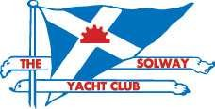
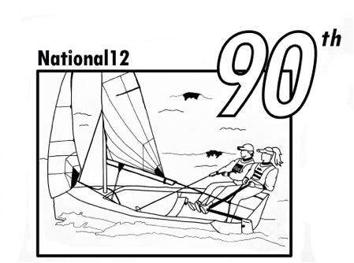

SOLWAY YACHT CLUB

NOTICE OF RACE

OPEN MEETING WEEKEND 12th/13th SEPTEMBER 2026 FOR NATIONAL 12s

A qualifying round of the National 12 “Old Spice” Northern Series and the “Witchcraft Bailer” series for Vintage and 4 Plankers National 12s

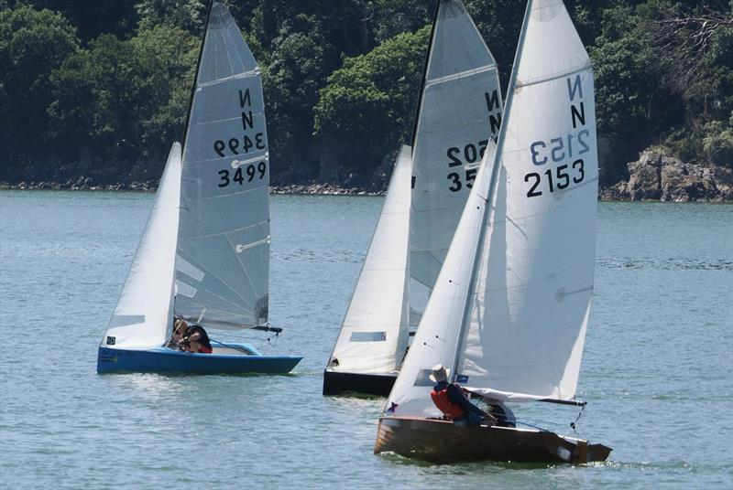

Solway Yacht Club, The Clubhouse, Kippford, Dalbeattie, Dumfries and Galloway
DG5 4LL
Tel: 01556 620312
www.thesyc.com

WELCOME
Solway Yacht Club invites you to join us for a weekend of good sailing in a setting of outstanding natural beauty. The large and comfortable clubhouse is in an elevated position with good views of the surrounding countryside. The Club site has a large boat park and offers excellent launching from pontoons and slipway. With a very active Cadet fleet, there is good availability of young crews, keen to sail National 12s

ACCOMMODATION & PARKING
There are many hotels and B&Bs within easy walking or motoring distance as well as caravan, camping and holiday chalets nearby, but early reservations are advised. There will be space for a limited number of campervans and tent pitches at the Clubhouse. Application for these spaces should be made to the Sailing Secretary (e-mail below) and will be allocated on a “first come, first served” basis.

There is limited car parking space at the clubhouse site, the roadside end of boat park and the public car park. Please respect local businesses’ interests. For the safety of competitors and spectators, vehicles may not be driven onto the pier area boat park other than to drop off or collect boats.

CATERING & BAR
Bacon butties will be available during Reception up to 10.30 on the Saturday. The racing will take place over the normal lunchtime period, It is planned to hold a barbecue social event on the Saturday evening (Tickets available via Webcollect). The prizegiving will be held as soon as possible after the end of the racing on the Sunday. Please note that the club has gone “cash free” so purchases on the day must be paid for by credit or bank card.

HOW TO FIND US
The Club’s Postcode is DG5 4LL. After coming down the hill into Kippford, the Clubhouse
entrance roadway is just before the entrance to a public car park at the foot of the hill on the left
and the boat park is on the right just round a sharp left-hand corner.

CONDITIONS
- The event will be open to all N12s holding a valid class certificate. Club Handicap Racing will be held at the same time but be given separate starts after the N12s. It is hoped to hold 2 races each day.

- The racing will be governed by the Racing Rules of Sailing (RRS) 2025 – 2028 and the event
Sailing Instructions. The latter may be made available online and paper copies will be available
at Reception together with waterproof course cards. The Advisory Hearing and RYA
Arbitration of the RYA Rules Disputes procedures shall apply (for information on the
procedures, go to www.rya.org.uk/go/rules). The outcome of an RYA Arbitration can be
referred to a protest committee, but an arbitration cannot be reopened or appealed.

3. The entrant will be deemed to be the helmsman named on the entry form.

4. Changes of boat or sail number must be notified in writing and will require the approval of the
Event Principal or deputy at Reception.

5. Personal buoyancy must be worn by all competitors. Boat buoyancy may be subject to
scrutiny. A suitable painter or tow rope of at least 5 metres must be carried on all boats to
facilitate towing and rescue.

6. A tally system may be used to ensure all competitors return safely after racing. If so
Competitors are obliged to use it and to cooperate fully with its requirements. Failure to do so
may result in disqualification.

7. Launching may be controlled by a Piermaster, and if so, competitors are asked to adhere to
his or her instructions. Priority should be given to the Club safety-boats, which will launch as
soon as the tide is high enough. Club racers will be asked to give the National 12s priority.
Launching trollies will be tagged, with tags supplied by the Club at Reception.

8. All entries should be made via Webcollect (link from the Club website). The Medical and
Consent form for under 18s should be completed online.

9. Any alterations to these conditions shall be at the sole discretion of the Commodore and
Race Committee of the Solway Yacht Club.

RACING PROGRAMME

Day | Date | Reception | Briefing | Warning Signal 1st Race^{x} | HW* | Height  m
Saturday | 12th Sept. | 09.30 | 10.30 | 11.35 | 13.15 | 8.5
Sunday | 13th Sept. | - | 11.45 | 12.10 | 13.50 | 8.4

*Estimated time; actual HW time can vary dependent on prevailing conditions.

Saturday’s Briefing will be held in the Clubhouse and Sunday’s on the Pier. Races will all be run from the Club start line. It can often take some time to reach the area, so crews should be ready to launch immediately after the Briefings. See Section 7 above. Please ensure boats are launched in sufficient time. In the event of light winds, tows may be available to help competitors reach the starting area, hence the need for carrying suitable tow ropes/painters (5m minimum required).

Subsequent races will start as soon as practicable after the end of the previous race.

ENTRY DEADLINE AND FEES
As already mentioned in Condition 8 above, all entries, except late ones (see Webcollect), should be made via Webcollect. They must be received by 20.00 on Thursday 10th September using the Link: https://webcollect.org.uk/syc and fees paid via Paypal or Bank Transfer, or by card at Reception on 12th September between 0930 and 10.00.

Late entries on the day before 10.00 using a paper entry form, replicating the Webcollect one, and payment by card will be accepted with an extra £5 cash donation to the RNLI.

Fees: Adults £40, Under 18s £20

For availability of crews, please contact Event Principal, Ian Purkis, c.ian.purkis@btinternet.com.

Telephone or e-mail queries and help using Webcollect, if needed, should be available up to 10th September from John Broadbent, Sailing Secretary, on 01556 630424 or sailingsec@thesyc.co.uk.

Solway Yacht Club, The Clubhouse, Kippford, Dalbeattie, Dumfries and Galloway
DG5 4LL
www.thesyc.com

SAILING AREA

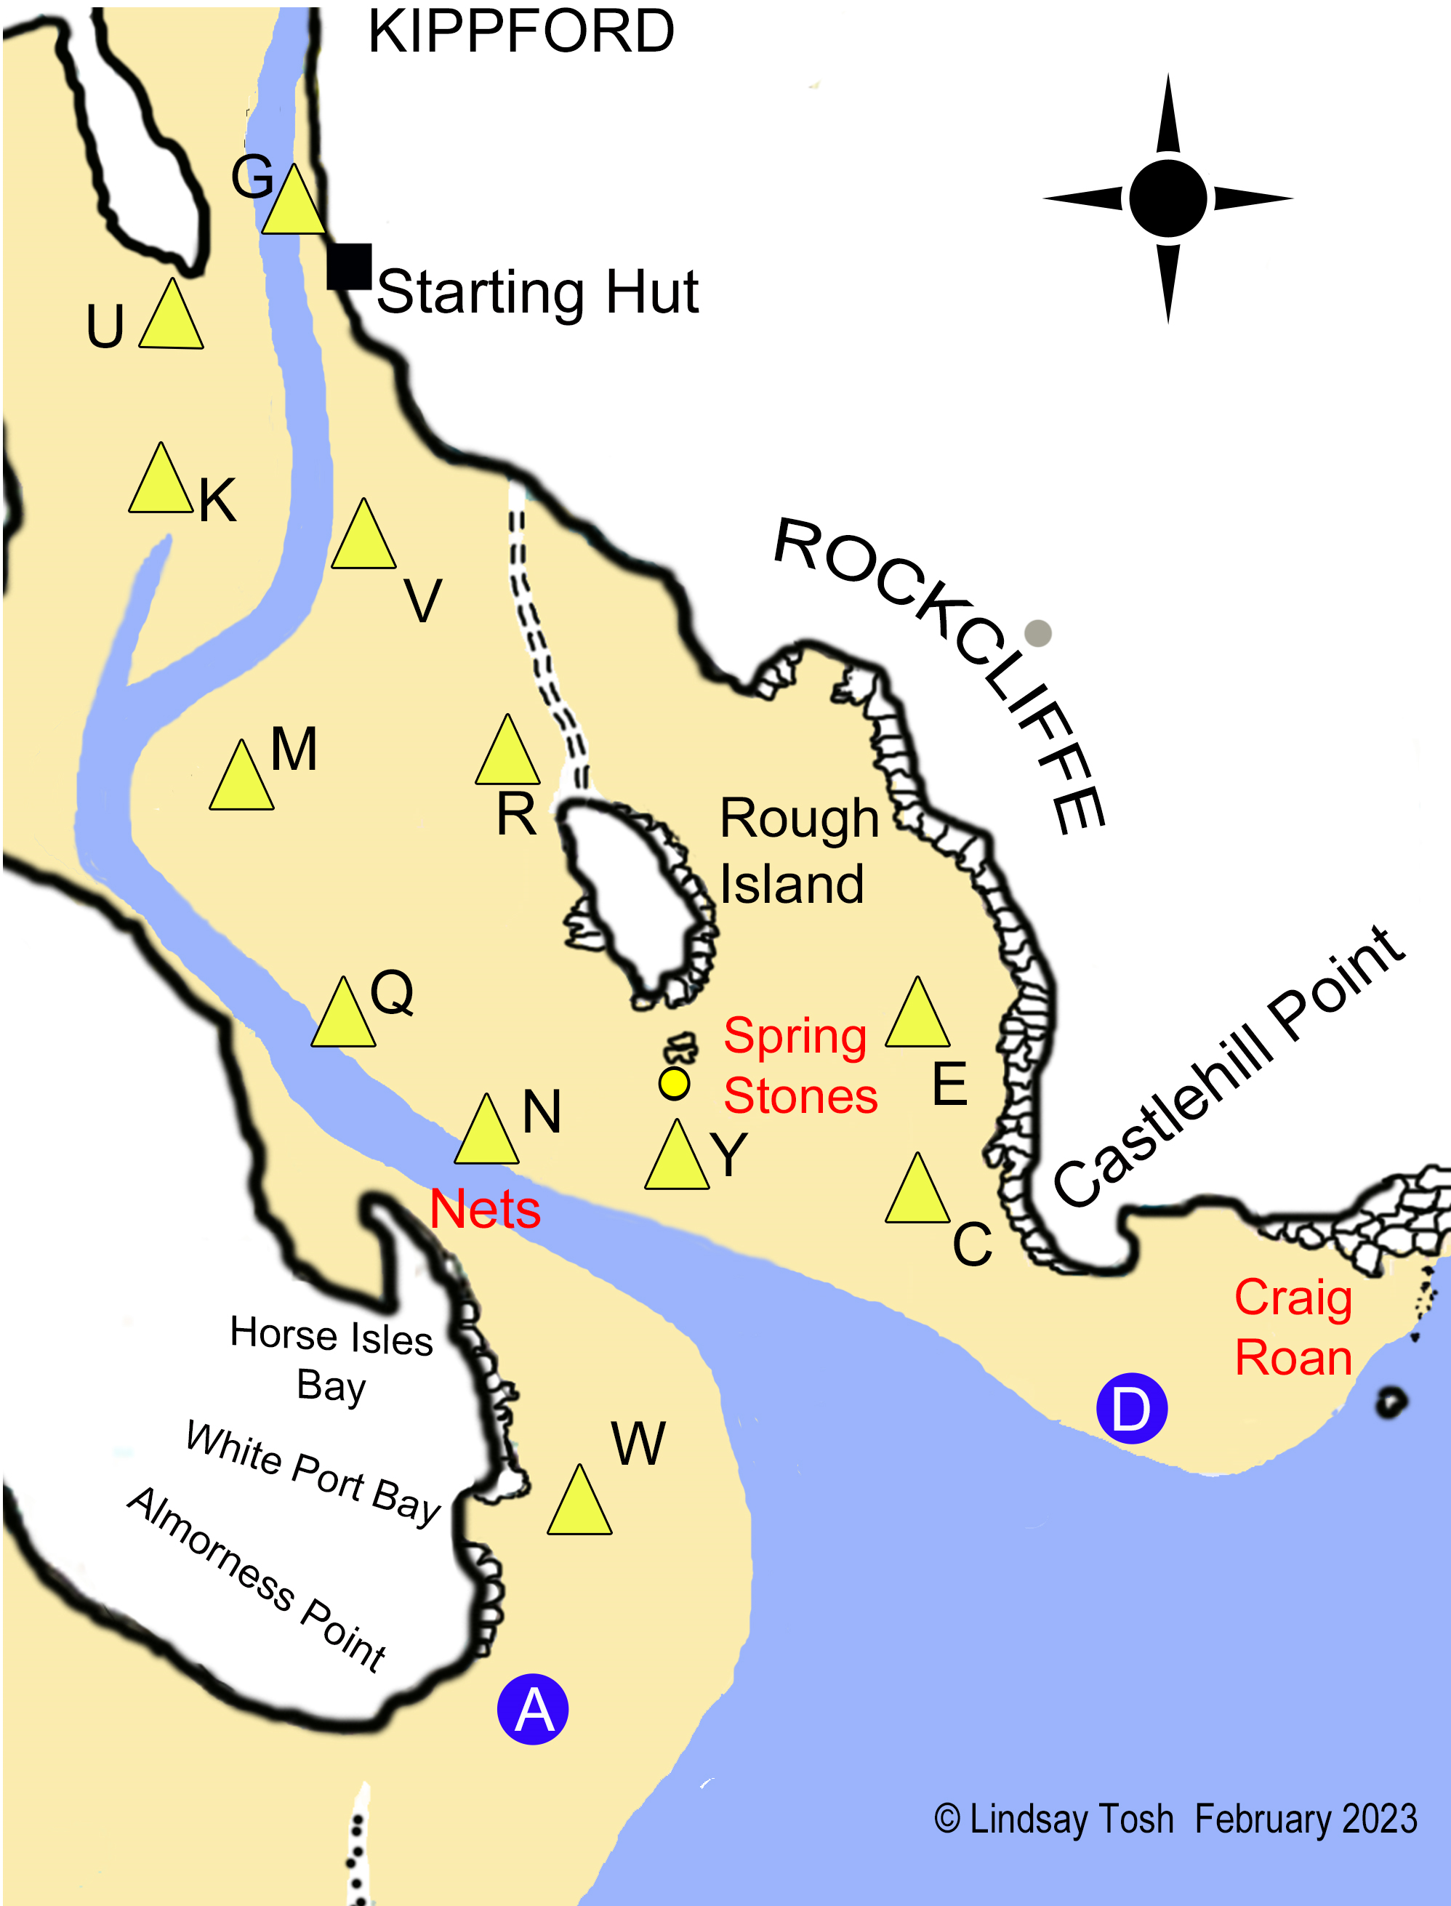

Note: The main channel now runs SW from G, past K, instead of taking the curved route shown above. The position of marks as shown are approximate only and not all may be laid.

