
GP14 Open Meeting
Trimpley SC
12th-July-2025
SAILING INSTRUCTIONS (SI)

These SI’s shall be read in conjunction with the NoR relating to this event

1 Rules

1.1 Distinguishing numbers: a boat may with the permission of the Race Committee use sails with a distinguishing mark other than the registered number of the boat.

1.2 Trimpley Sailing Club supports the RYA Racing Charter & that when entering, competitors undertake to sail in compliance with the Charter.

2 NoticeS to competitors

2.1 Notices to competitors will be posted on the official notice board located in the Club House.

3 Changes to Sailing instructions (SI’s)
3.1 Any changes to the SI’s will be posted at least 30 minutes before the warning signal of a race it will affect.

4 Signals Made

4.1 Signals made will be displayed at the Race Control Hut, unless otherwise advised at the Briefing.

5 Safety, Disclaimer of Liability & INSURANCE

5.1 See NoR 10 Risk Statement

5.2 See NoR 11 Insurance

6 Schedule of Races
Starting and Recalls
6.1 The warning signal for the first race shall not be before the time advised in the Notice of Race. The intended schedule of subsequent races that follow will be announced at the briefing.
6.2 RRS 29 Recalls applies

7 CLASS Flags
7.1 The flag(s) will be displayed at the briefing.

8 Sailing Area & Obstructions
8.1 The sailing area is the full extent of the reservoir.
8.2 The two towers and access bridges in the reservoir rank as obstructions

8.3 A 5m Obstruction Zone must be observed around these structures.

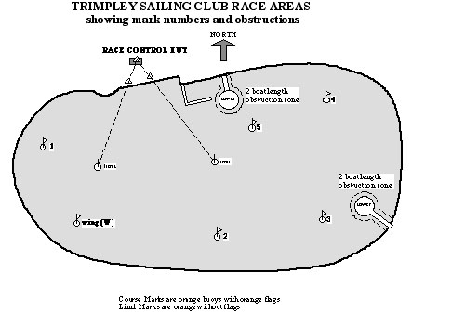

The Course & MARKS

9.1 The course will be displayed on the Race Control Hut no later than the warning signal. The mark numbers or letters shall be displayed in sequence, their background colour ‘Red’ or ‘Green’ indicating whether marks are to be passed to port or starboard respectively.

9.2 The intended number of laps will be determined by time.

9.3 The ‘target’ time of each race will be approximately 50 minutes for the first boat that sails the course and finishes.

9.4 The Race Officer may signal shortened course (Flag S) at an appropriate time to achieve this ‘target’. Not achieving or exceeding this ‘target’ time will not give cause to seek redress or protest. This changes RRS 60.1 and RRS 61.1
9.3 Course marks – Course marks are orange round buoys, labelled and laid out approximately as shown above.
9.4 Start Line marks - The mark used for the starting line will be a round buoy, and a staff on the Committee boat or Race Hut. This will be determined at the Race Briefing.
9.5 Finish Line mark
The marks used for the finishing line will be a mark of the course and the Committee boat or the Race Control Hut and the Finish Line Mark (marked L).

10 The Start

10.1 The Starting Line – will be between a staff on the committee boat displaying an orange flag or the Race Control Hut or a staff on the shore and the start line mark. This will be confirmed at the briefing

10.2 The starting sequence will be as RRS 26. 5, 4, 1, 0

10.3 A boat that starts later than 4 minutes after the starting signal will be scored Did Not Start without a hearing. This changes RRS 61.1

11 Change of position of mark
11.1 No marks of the course will be moved after the warning signal.

12 SHORTEN COURSE
12.1 The Shorten Course shall be signalled ) before the leading boat enters the 3 boat length zone of a mark of the course.
12.2 The leading boat and all other boats will leave the mark on the required side and sail to the finish line without being required to pass or round any other marks crossing the line in the direction as sailed from the last mark.

13 The Finish

13.1 The Finishing Line – will be between the staff on the Committee Boat flying an blue flag or the Race Control Hut and the finish line mark.

13.2 Sound Signal – Boats crossing the finishing line may be acknowledged with a sound signal. This does not imply correct completion of the race or otherwise.

14 Race Time Limit
14.1 Race time limit will be 65 minutes.
14.2 If no boat finishes within the race time limit, the race committee shall abandon the race.
14.3 Boats failing to finish within 15 minutes after the first boat that sails the course and finishes will be classified as Did Not Finish (DNF). This amends RRS 35.
14.2 A boat that retires from a race shall notify the Race Committee at the first reasonable opportunity.

15 PROTESTS, REDRESS, Hearings, MISCONDUCT AND APPEALS
15.1 Requests for protests or redress under RRS 60 or RRS61 must be made in writing on the form available from the Race Hut.

15.2 Completed protest forms shall be lodged with the Race Officer or their representative at the race office at Trimpley Sailing Club within the protest time limit.

15.3 The protest time limit is 30 minutes after the last boat finishes the last race of that day or the race officer signals no more racing today.

15.4 Hearing notices will be posted no later than 30 minutes after the end of the protest time limit to inform competitors and parties and named witnesses of the time and location of the Hearing.

15.5 Appendix T Arbitration Hearing will apply before a protest meeting

16 DECLARATIONS

16.1 Declarations are not required.

17 SCORING
17.1 See NoR 8 Scoring

18 SUBSTITUTIONS OF COMPETITORS or BOAT
18.1 Changing of helm - A change of helm is classified as a new entry.
18.2 Substitution of damaged or lost equipment will not be allowed unless authorised by the Race Committee. Requests for substitution shall be made to the Race Committee at the first reasonable opportunity.

